Model I EX 요구사항

* Customer 관련 :회원가입, 로그인, 정보수정, 로그아웃, 회원리스트보기
* 고객센터(파일첨부게시판) – 글쓰기, 답변글쓰기, 글목록(페이징추가), 글수정, 글 삭제
* 도서등록, 도서리스트보기(페이징), 도서상세보기
* 로그인한 사람만 도서등록과 글쓰기(원글, 답변글)가 가능하다
* 글수정은 내가 쓴 글만 수정 가능하다.
* 글삭제는 내가 쓴 글이 아니여도, 로그인전이여도, 삭제용비번만 알면 삭제 가능
* header의 gnb와 footer의 배경색은 #003300

실행화면 캡쳐

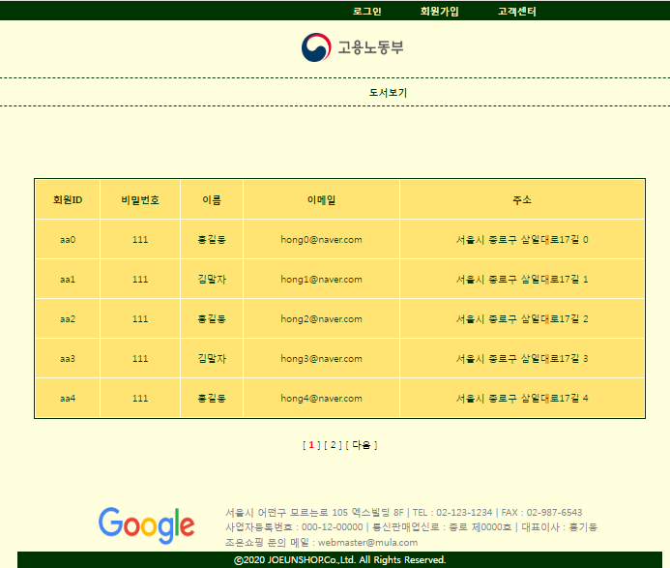 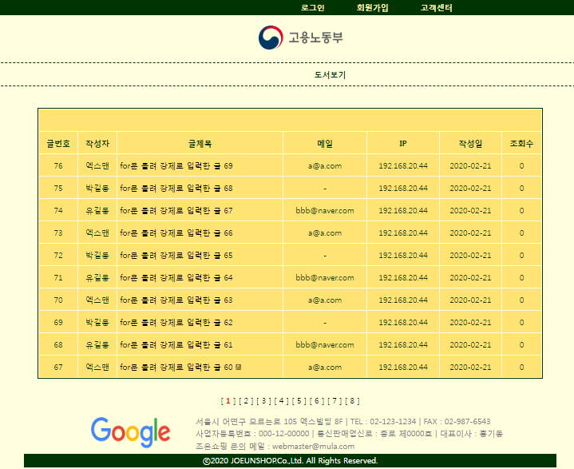

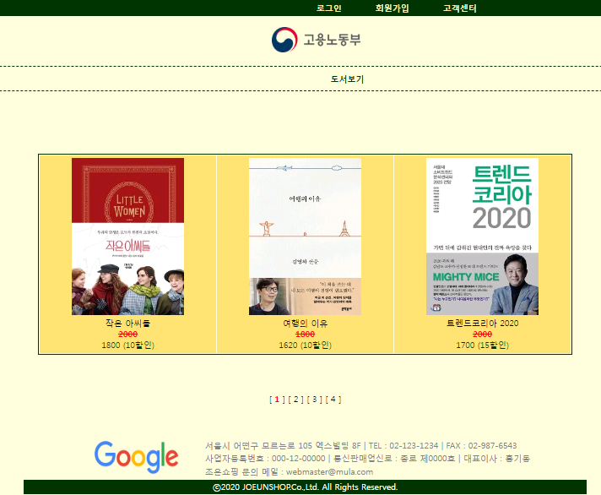 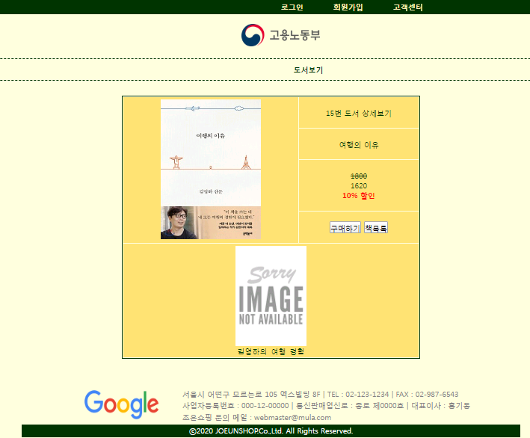

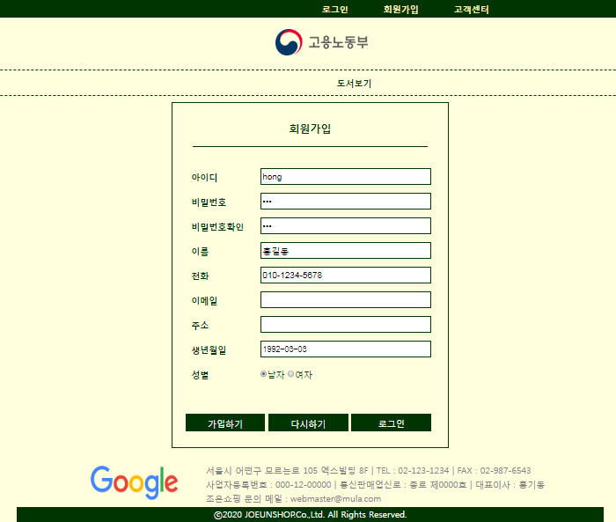 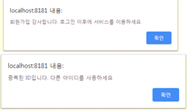

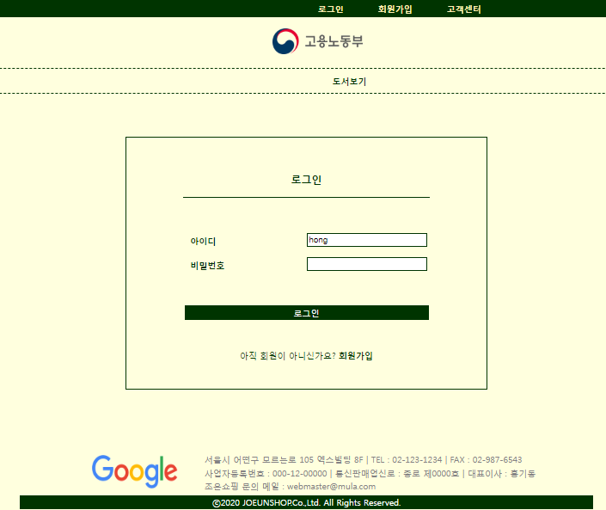 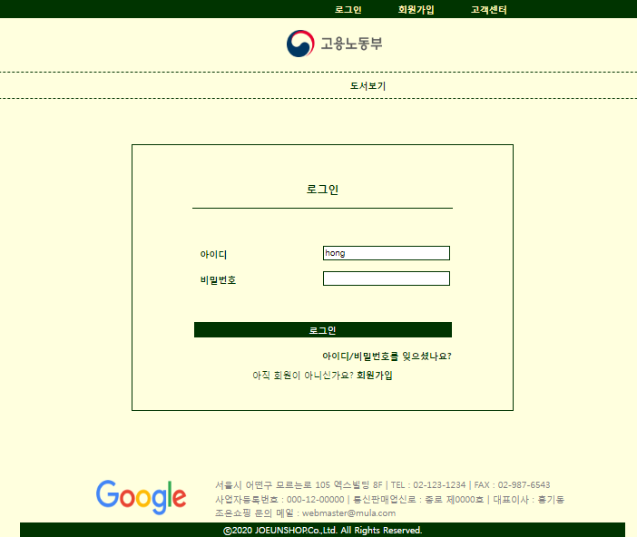

로그인 후 해더 변경, 도서등록 메뉴 생기고 글쓰기 생김

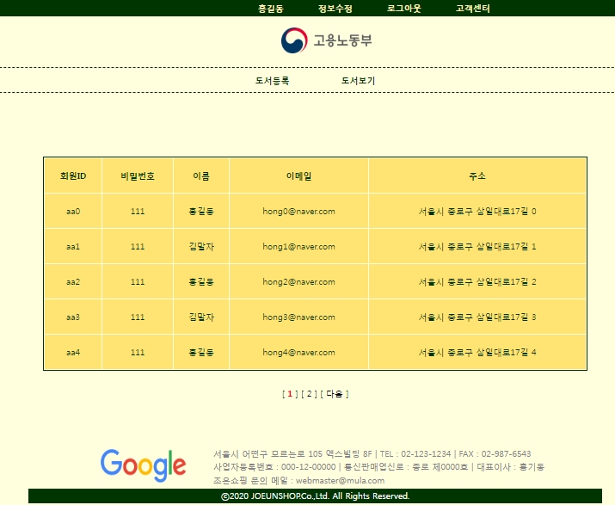 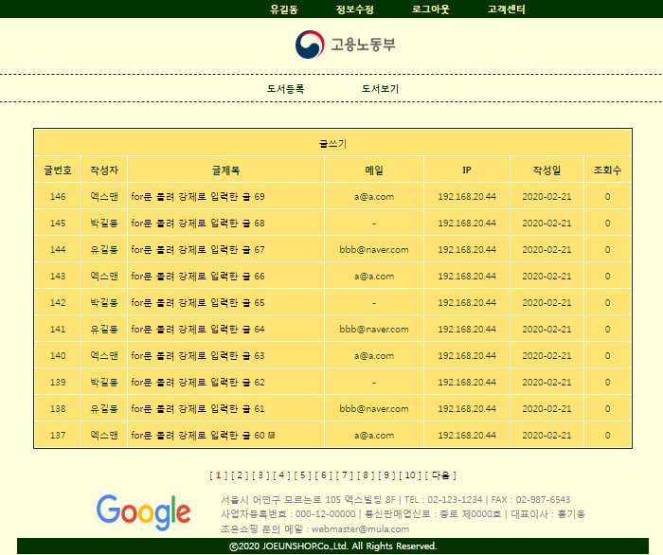

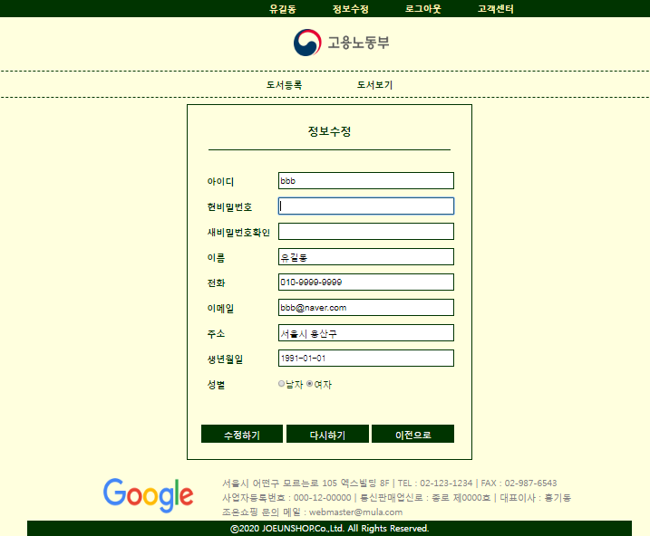 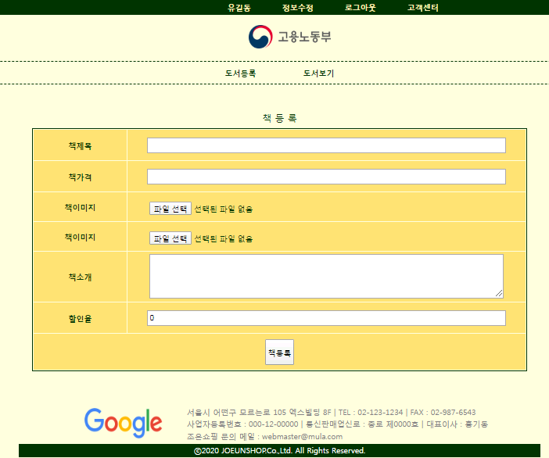

* 로그인 전 글 상세보기 페이지엔 답변버튼이 없다. 내가 쓴 글이 아니면 수정버튼도 없다
* 첨부파일이 없을 경우 “첨부파일 없음”라고 출력
* 로그인 한 후 고객센터 게시판 : 수정(본인 글만 수정), 답변(로그인 후), 삭제(비번알면 타인글도 로그인 전도 가능)

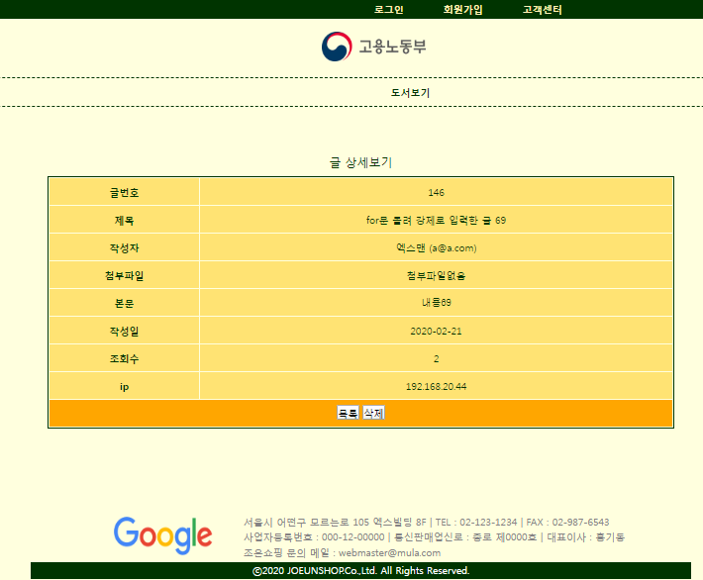 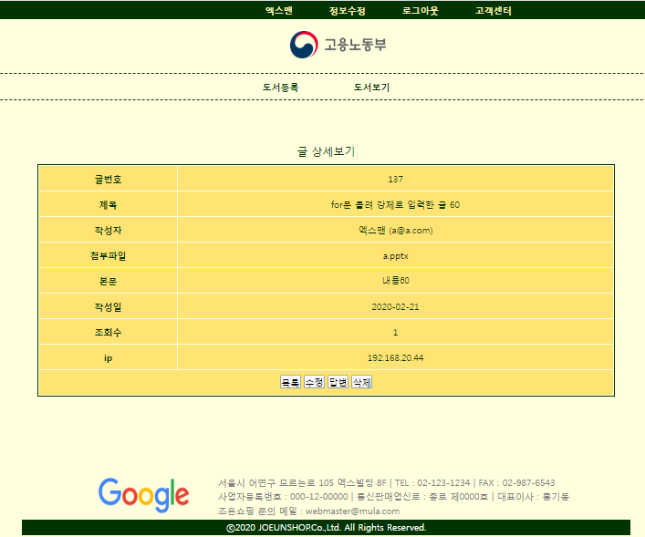

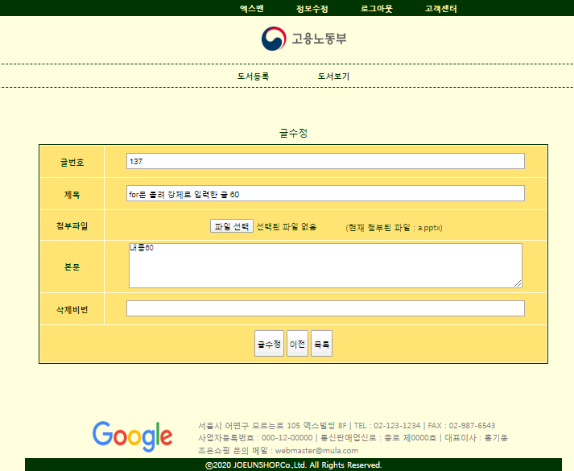 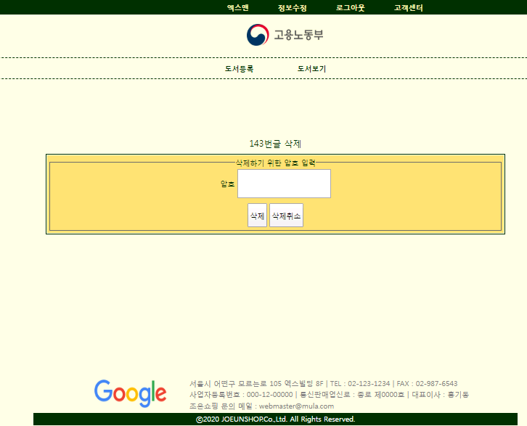

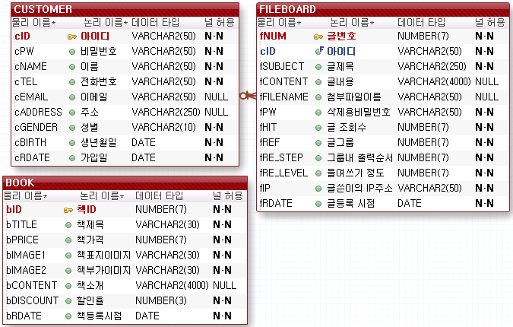

**테이블 생성**

**DROP** **TABLE** FILEBOARD;

**DROP** **TABLE** CUSTOMER;

**DROP** **TABLE** BOOK **CASCADE** CONSTRAINTS;

**DROP** SEQUENCE BOOK_SEQ;

**CREATE** SEQUENCE BOOK_SEQ MAXVALUE 9999999 NOCACHE NOCYCLE;

**CREATE** **TABLE** BOOK(

bID NUMBER(7) **PRIMARY** **KEY**, -- 책아이디

bTITLE VARCHAR2(30) **NOT** **NULL**, -- 책제목

bPRICE NUMBER(7) **NOT** **NULL**, -- 책가격

bIMAGE1 VARCHAR2(30) **DEFAULT** 'NOTHING.JPG' **NOT** **NULL**, -- 책대표이미지

bIMAGE2 VARCHAR2(30) **DEFAULT** 'noImg.png' **NOT** **NULL**, -- 책부가이미지

bCONTENT VARCHAR2(4000), -- 책설명

bDISCOUNT NUMBER(3) **NOT** **NULL**, -- 할인율

bRDATE **DATE** **DEFAULT** SYSDATE); -- 책 등록일

**CREATE** **TABLE** CUSTOMER(

CID VARCHAR2(50) **PRIMARY** **KEY**,

CPW VARCHAR2(50) **NOT** **NULL**,

CNAME VARCHAR2(50) **NOT** **NULL**,

CTEL VARCHAR2(50) **NOT** **NULL**,

CEMAIL VARCHAR2(50),

CADDRESS VARCHAR2(250),

CGENDER VARCHAR2(10) **NOT** **NULL**,

CBIRTH **DATE** **NOT** **NULL**,

CRDATE **DATE** **DEFAULT** SYSDATE

);

**DROP** SEQUENCE FILEBOARD_SEQ;

**CREATE** SEQUENCE FILEBOARD_SEQ MAXVALUE 9999999 NOCACHE NOCYCLE;

**CREATE** **TABLE** FILEBOARD(

fNUM NUMBER(7) **PRIMARY** **KEY**,

cID VARCHAR2(50) **REFERENCES** CUSTOMER(cID),

fSUBJECT VARCHAR2(250) **NOT** **NULL**,

fCONTENT VARCHAR2(4000),

fFILENAME VARCHAR2(50),

fPW VARCHAR2(50) **NOT** **NULL**,

fHIT NUMBER(7) **DEFAULT** 0 **NOT** **NULL**,

fREF NUMBER(7) **NOT** **NULL**,

fRE_STEP NUMBER(7) **NOT** **NULL**,

fRE_LEVEL NUMBER(7) **NOT** **NULL**,

fIP VARCHAR2(50) **NOT** **NULL**,

fRDATE **DATE** **DEFAULT** SYSDATE **NOT** **NULL**);

DAO

-- ★ 고객(Customer) 관련

-- 1. 회원가입시 id 중복체크를 위한 SQL

**SELECT** * **FROM** CUSTOMER **WHERE** CID='aaa';

-- 2. 회원가입 SQL

**INSERT** **INTO** CUSTOMER (CID, CPW, CNAME, CTEL, CEMAIL, CADDRESS, CGENDER, CBIRTH)

**VALUES** ('aaa','111','홍길동','010-9999-9999', 'aaa@abc.com', '서울시 종로구','m','1991-01-01');

-- 3. 로그인할 때 (ID/PW)

**SELECT** * **FROM** CUSTOMER **WHERE** CID='aaa' **and** CPW='111';

-- 4. ID로 DTO 가져오기

**SELECT** * **FROM** CUSTOMER **WHERE** CID='aaa';

-- 5. 회원정보 수정

**UPDATE** CUSTOMER **SET** CPW='111',

CNAME='엑스맨',

CTEL = '010-9999-1111',

CEMAIL='a@a.com',

CADDRESS='서울시 용산구',

CBIRTH=to_date('1992-03-12','yyyy-mm-dd'),

CGENDER = 'm'

**WHERE** CID='aaa';

-- 6. 회원리스트 보기(startRow부터 endRow 목록보기)

**SELECT** * **FROM** CUSTOMER **ORDER** **BY** CID;

**SELECT** * **FROM** (**SELECT** ROWNUM RN, A.* **FROM** (**SELECT** * **FROM** CUSTOMER **ORDER** **BY** CID) A)

**WHERE** RN **BETWEEN** 4 **AND** 6;

-- 7. 등록된 회원 명수 가져오기

**SELECT** COUNT(*) TOTCNT **FROM** CUSTOMER;

-- ★ 도서(Book) 관련

-- 1. 책등록

**INSERT** **INTO** BOOK (bID, bTITLE, bPRICE, bIMAGE1, bIMAGE2, bCONTENT, bDISCOUNT)

**VALUES** (BOOK_SEQ.NEXTVAL, '이것은자바다',20000,'NOTHING.JPG','noImg.png','좋아',10);

-- 2.책목록(TOP-N) : 페이징

**SELECT** * **FROM** (**SELECT** ROWNUM RN, A.* **FROM** (**SELECT** * **FROM** BOOK **ORDER** **BY** bRDATE **DESC**) A)

**WHERE** RN **BETWEEN** 2 **AND** 3;

-- 3. 등록된 책 갯수

**SELECT** COUNT(*) **FROM** BOOK;

-- 4. bID로 책 가져오기

**SELECT** * **FROM** BOOK **WHERE** bID=3;

-- ★ 게시판(FileBoard) 관련

--1. 글목록(startRow부터 endRow까지 목록)

**SELECT** F.*, CNAME, cemail **FROM** FILEBOARD F, CUSTOMER C

**WHERE** F.CID=C.CID **ORDER** **BY** fREF **DESC**, fRE_STEP; -- 목록 출력 기준

**SELECT** * **FROM** (**SELECT** ROWNUM RN, A.* **FROM**

(**SELECT** F.*, CNAME, cemail **FROM** FILEBOARD F, CUSTOMER C

**WHERE** F.CID=C.CID **ORDER** **BY** fREF **DESC**, fRE_STEP) A)

**WHERE** RN **BETWEEN** 2 **AND** 4; -- DAO에 쓸 QUERY

-- 2. 등록된 글 갯수

**SELECT** COUNT(*) **FROM** FILEBOARD;

-- 3. 원글쓰기

**INSERT** **INTO** FILEBOARD (fNUM, cID, fSUBJECT, fCONTENT, fFILENAME, fPW,

fREF, fRE_STEP, fRE_LEVEL, fIP)

**VALUES** (FILEBOARD_SEQ.NEXTVAL, 'aaa', 'titile','',**null**,'111',

FILEBOARD_SEQ.CURRVAL, 0,0, '192.168.20.44');

-- 4. 답변글 쓰기전 STEP ⓐ 수행(REF가 같고 원글의 RE_STEP보다 많은 경우 RE_STEP++)

**UPDATE** FILEBOARD **SET** fRE_STEP = fRE_STEP+1

**WHERE** fREF=3 **AND** fRE_STEP>0;

**SELECT** * **FROM** FILEBOARD **WHERE** fREF=3;

-- 4. 답변글쓰기

**INSERT** **INTO** FILEBOARD

(fNUM, cID, fSUBJECT, fCONTENT, fFILENAME, fPW, fREF, fRE_STEP, fRE_LEVEL, fIP)

**VALUES** (FILEBOARD_SEQ.NEXTVAL, 'ddd', '답3-1','',**NULL**,'111',3, 1, 1, '127.0.0.1');

**SELECT** * **FROM** FILEBOARD **ORDER** **BY** fREF **DESC**, fRE_STEP;

-- 5. 글 상세보기(글번호로 DTO가져오기)

**SELECT** F.*, cNAME, cEMAIL **FROM** FILEBOARD F, CUSTOMER C

**WHERE** F.cID=C.cID **AND** fNUM=3;

-- 5. 조회수 올리기

**UPDATE** FILEBOARD **SET** fHIT = fHIT+1 **WHERE** fNUM=3;

-- 6. 글 수정하기

**UPDATE** FILEBOARD **SET** fSUBJECT = '바뀐제목',

fCONTENT = '바뀐내용',

fFILENAME = **NULL**,

fPW = '111',

fIP = '127.0.0.1'

**WHERE** fNUM=3;

**SELECT** * **FROM** FILEBOARD;

--7. 글삭제

**DELETE** **FROM** FILEBOARD **WHERE** fNUM=6 **AND** fPW='111';

프로젝트 구성요소

* DTO3개(BookDto,CustomerDto,FileboardDto), DAO 3개(BookDao,CustomerDao,FileboardDao)는 src폴더에 아래의 폴더는 WebContent폴더에
* img 폴더 - 이 프로그램에서 필요한 이미지들(로고, hot.gif, level.gif, re.gif)
* main 폴더 - footer.jsp
* header.jsp
* main.jsp(첫화면)
* customer폴더 - joinForm.jsp
  + - * + joinPro.jsp
        + loginForm.jsp
        + loginPro.jsp
        + logout.jsp
        + modifyForm.jsp
        + modifyPro.jsp
* book폴더 - bookList.jsp
  + - * bookRegister.jsp
      * bookRegisterPro.jsp
      * bookContent.jsp
* bookImg폴더 - 도서등록시 업로드할 파일들이 저장될 폴더
* fileboard폴더 – fboardList.jsp
  + - * + fboardContent.jsp
        + fboardDeleteForm.jsp
        + fboardDeletePro.jsp
        + fboardUpdateForm.jsp
        + fboardUpdatePro.jsp
        + fboardWriteForm.jsp
        + fboardWritePro.jsp
* fileboardUpload 폴더- 파일첨부게시판에서 첨부한 파일들이 저장될 폴더
* 그 외 css

**(BootDto.java)**

**package** com.tj.model1ex.dto;

**import** java.sql.Date;

**public** **class** BookDto {

**private** **int** bid;

**private** String btitle;

**private** **int** bprice;

**private** String bimage1;

**private** String bimage2;

**private** String bcontent;

**private** **int** bdiscount;

**private** Date brdate;

**public** BookDto() {}

**public** BookDto(**int** bid, String btitle, **int** bprice, String bimage1, String bimage2, String bcontent, **int** bdiscount,

Date brdate) {

**this**.bid = bid;

**this**.btitle = btitle;

**this**.bprice = bprice;

**this**.bimage1 = bimage1;

**this**.bimage2 = bimage2;

**this**.bcontent = bcontent;

**this**.bdiscount = bdiscount;

**this**.brdate = brdate;

}

**public** **int** getBid() {**return** bid;}

**public** **void** setBid(**int** bid) {**this**.bid = bid;}

**public** String getBtitle() {**return** btitle;}

**public** **void** setBtitle(String btitle) {**this**.btitle = btitle;}

**public** **int** getBprice() {**return** bprice;}

**public** **void** setBprice(**int** bprice) {**this**.bprice = bprice;}

**public** String getBimage1() {**return** bimage1;}

**public** **void** setBimage1(String bimage1) {**this**.bimage1 = bimage1;}

**public** String getBimage2() {**return** bimage2;}

**public** **void** setBimage2(String bimage2) {**this**.bimage2 = bimage2;}

**public** String getBcontent() {**return** bcontent;}

**public** **void** setBcontent(String bcontent) {**this**.bcontent = bcontent;}

**public** **int** getBdiscount() {**return** bdiscount;}

**public** **void** setBdiscount(**int** bdiscount) {**this**.bdiscount = bdiscount;}

**public** Date getBrdate() {**return** brdate;}

**public** **void** setBrdate(Date brdate) {**this**.brdate = brdate;}

@Override

**public** String toString() {

**return** "BookDto [bid=" + bid + ", btitle=" + btitle + ", bprice=" + bprice + ", bimage1=" + bimage1

+ ", bimage2=" + bimage2 + ", bcontent=" + bcontent + ", bdiscount=" + bdiscount + ", brdate=" + brdate

+ "]";

}

}

**(CustomerDto.java)**

**public** **class** CustomerDto {

**private** String cid;

**private** String cpw;

**private** String cname;

**private** String ctel;

**private** String cemail;

**private** String caddress;

**private** Date cbirth;

**private** String cgender;

**private** Timestamp crdate;

**public** CustomerDto() { }

**public** CustomerDto(String cid, String cpw, String cname, String ctel, String cemail, String caddress, Date cbirth,

String cgender, Timestamp crdate) {

**super**();

**this**.cid = cid;

**this**.cpw = cpw;

**this**.cname = cname;

**this**.ctel = ctel;

**this**.cemail = cemail;

**this**.caddress = caddress;

**this**.cbirth = cbirth;

**this**.cgender = cgender;

**this**.crdate = crdate;

}

**public** String getCid() {**return** cid;}

**public** **void** setCid(String cid) {**this**.cid = cid;}

**public** String getCpw() {**return** cpw;}

**public** **void** setCpw(String cpw) {**this**.cpw = cpw;}

**public** String getCname() {**return** cname;}

**public** **void** setCname(String cname) {**this**.cname = cname;}

**public** String getCtel() {**return** ctel;}

**public** **void** setCtel(String ctel) {**this**.ctel = ctel;}

**public** String getCemail() {**return** cemail;}

**public** **void** setCemail(String cemail) {**this**.cemail = cemail;}

**public** String getCaddress() {**return** caddress;}

**public** **void** setCaddress(String caddress) {**this**.caddress = caddress;}

**public** String getCgender() {**return** cgender;}

**public** **void** setCgender(String cgender) {**this**.cgender = cgender;}

**public** Date getCbirth() {**return** cbirth;}

**public** **void** setCbirth(Date cbirth) {**this**.cbirth = cbirth;}

**public** Timestamp getCrdate() {**return** crdate;}

**public** **void** setCrdate(Timestamp crdate) {**this**.crdate = crdate;}

@Override

**public** String toString() {

**return** cid + "(cid) " + cpw + ", cname=" + cname + ", ctel=" + ctel + ", cemail=" + cemail

+ ", caddress=" + caddress + ", cbirth=" + cbirth + ", crdate=" + crdate + "]";

}

}

**(FileBoardDto.java)**

**package** com.tj.model1ex.dto;

**import** java.sql.Date;

**public** **class** FileBoardDto {

**private** **int** fnum;

**private** String cid;

**private** String fsubject;

**private** String fcontent;

**private** String ffilename;

**private** String fpw;

**private** **int** fhit;

**private** **int** fref;

**private** **int** fre_step;

**private** **int** fre_level;

**private** String fip;

**private** Date frdate;

**private** String cname;

**private** String cemail;

**public** FileBoardDto() {}

**public** FileBoardDto(**int** fnum, String cid, String fsubject, String fcontent, String ffilename, String fpw, **int** fhit,

**int** fref, **int** fre_step, **int** fre_level, String fip, Date frdate, String cname, String cemail) {

**this**.fnum = fnum;

**this**.cid = cid;

**this**.fsubject = fsubject;

**this**.fcontent = fcontent;

**this**.ffilename = ffilename;

**this**.fpw = fpw;

**this**.fhit = fhit;

**this**.fref = fref;

**this**.fre_step = fre_step;

**this**.fre_level = fre_level;

**this**.fip = fip;

**this**.frdate = frdate;

**this**.cname = cname;

**this**.cemail = cemail;

}

**public** **int** getFnum() {**return** fnum;}

**public** **void** setFnum(**int** fnum) {**this**.fnum = fnum;}

**public** String getCid() {**return** cid;}

**public** **void** setCid(String cid) {**this**.cid = cid;}

**public** String getFsubject() {**return** fsubject;}

**public** **void** setFsubject(String fsubject) {**this**.fsubject = fsubject;}

**public** String getFcontent() {**return** fcontent;}

**public** **void** setFcontent(String fcontent) {**this**.fcontent = fcontent;}

**public** String getFfilename() {**return** ffilename;}

**public** **void** setFfilename(String ffilename) {**this**.ffilename = ffilename;}

**public** String getFpw() {**return** fpw;}

**public** **void** setFpw(String fpw) {**this**.fpw = fpw;}

**public** **int** getFhit() {**return** fhit;}

**public** **void** setFhit(**int** fhit) {**this**.fhit = fhit;}

**public** **int** getFref() {**return** fref;}

**public** **void** setFref(**int** fref) {**this**.fref = fref;}

**public** **int** getFre_step() {**return** fre_step;}

**public** **void** setFre_step(**int** fre_step) {**this**.fre_step = fre_step;}

**public** **int** getFre_level() {**return** fre_level;}

**public** **void** setFre_level(**int** fre_level) {**this**.fre_level = fre_level;}

**public** String getFip() {**return** fip;}

**public** **void** setFip(String fip) {**this**.fip = fip;}

**public** Date getFrdate() {**return** frdate;}

**public** **void** setFrdate(Date frdate) {**this**.frdate = frdate;}

**public** String getCname() {**return** cname;}

**public** **void** setCname(String cname) {**this**.cname = cname;}

**public** String getCemail() {**return** cemail;}

**public** **void** setCemail(String cemail) {**this**.cemail = cemail;}

@Override

**public** String toString() {

**return** "FileBoardDto [fnum=" + fnum + ", cid=" + cid + ", fsubject=" + fsubject + ", fcontent=" + fcontent

+ ", ffilename=" + ffilename + ", fpw=" + fpw + ", fhit=" + fhit + ", fref=" + fref + ", fre_step="

+ fre_step + ", fre_level=" + fre_level + ", fip=" + fip + ", frdate=" + frdate + ", cname=" + cname

+ ", cemail=" + cemail + "]";

}

}

**(BookDao.java)**

**public** **class** BookDao {

**public** **static** **final** **int** ***SUCCESS*** = 1;

**public** **static** **final** **int** ***FAIL*** = 0;

**private** **static** BookDao *instance*;

**public** **static** BookDao getInstance() {

**if**(*instance*==**null**) {

*instance* = **new** BookDao();

}

**return** *instance*;

}

**private** BookDao() {}

**private** Connection getConnection() **throws** SQLException {

Connection conn = **null**;

**try** {

Context ctx = **new** InitialContext();

DataSource ds = (DataSource) ctx.lookup("java:comp/env/jdbc/Oracle11g");

conn = ds.getConnection();

} **catch** (NamingException e) {

System.***out***.println(e.getMessage());

}

**return** conn;

}

// 책등록

**public** **int** insertBook(BookDto book) {

**int** result = ***FAIL***;

Connection conn = **null**;

PreparedStatement pstmt = **null**;

String sql = "INSERT INTO BOOK "

+ "(bID, bTITLE, bPRICE, bIMAGE1, bIMAGE2, bCONTENT, bDISCOUNT) "

+ "VALUES (BOOK_SEQ.NEXTVAL, ?,?,?,?,?,?)";

**try** {

conn = getConnection();

pstmt = conn.prepareStatement(sql);

pstmt.setString(1, book.getBtitle());

pstmt.setInt(2, book.getBprice());

pstmt.setString(3, book.getBimage1());

pstmt.setString(4, book.getBimage2());

pstmt.setString(5, book.getBcontent());

pstmt.setInt(6, book.getBdiscount());

result = pstmt.executeUpdate();

System.***out***.println(result==***SUCCESS***? "책등록성공":"책등록실패");

} **catch** (SQLException e) {

System.***out***.println(e.getMessage());

System.***out***.println("책등록실패 : "+book);

} **finally** {

**try** {

**if**(pstmt!= **null**) pstmt.close();

**if**(conn != **null**) conn.close();

}**catch** (SQLException e) {

System.***out***.println(e.getMessage());

}

}

**return** result;

}

// 책목록(전체)

**public** ArrayList<BookDto> listBook(){

ArrayList<BookDto> books = **new** ArrayList<BookDto>();

Connection conn = **null**;

PreparedStatement pstmt = **null**;

ResultSet rs = **null**;

String sql = "SELECT * FROM BOOK ORDER BY bRDATE DESC";

**try** {

conn = getConnection();

pstmt = conn.prepareStatement(sql);

rs = pstmt.executeQuery();

**while**(rs.next()) {

**int** bid = rs.getInt("bid");

String btitle = rs.getString("btitle");

**int** bprice = rs.getInt("bprice");

String bimage1 = rs.getString("bimage1");

String bimage2 = rs.getString("bimage2");

String bcontent= rs.getString("bcontent");

**int** bdiscount = rs.getInt("bdiscount");

Date brdate = rs.getDate("brdate");

books.add(**new** BookDto(bid, btitle, bprice, bimage1, bimage2,

bcontent, bdiscount, brdate));

// BookDto book = new BookDto();

// book.setBid(rs.getInt("bid"));

// book.setBtitle(rs.getString("btitle"));

//...

// books.add(book);

}

} **catch** (SQLException e) {

System.***out***.println(e.getMessage());

} **finally** {

**try** {

**if**(rs != **null**) rs.close();

**if**(pstmt!= **null**) pstmt.close();

**if**(conn != **null**) conn.close();

}**catch** (SQLException e) {

System.***out***.println(e.getMessage());

}

}

**return** books;

}

// 책목록(페이징:startRow~endRow)

**public** ArrayList<BookDto> listBook(**int** startRow, **int** endRow){

ArrayList<BookDto> books = **new** ArrayList<BookDto>();

Connection conn = **null**;

PreparedStatement pstmt = **null**;

ResultSet rs = **null**;

String sql = "SELECT * FROM "

+ "(SELECT ROWNUM RN, A.* FROM "

+ "(SELECT * FROM BOOK ORDER BY bRDATE DESC) A)" +

" WHERE RN BETWEEN ? AND ?";

**try** {

conn = getConnection();

pstmt = conn.prepareStatement(sql);

pstmt.setInt(1, startRow);

pstmt.setInt(2, endRow);

rs = pstmt.executeQuery();

**while**(rs.next()) {

**int** bid = rs.getInt("bid");

String btitle = rs.getString("btitle");

**int** bprice = rs.getInt("bprice");

String bimage1 = rs.getString("bimage1");

String bimage2 = rs.getString("bimage2");

String bcontent= rs.getString("bcontent");

**int** bdiscount = rs.getInt("bdiscount");

Date brdate = rs.getDate("brdate");

books.add(**new** BookDto(bid, btitle, bprice, bimage1, bimage2,

bcontent, bdiscount, brdate));

// BookDto book = new BookDto();

// book.setBid(rs.getInt("bid"));

// book.setBtitle(rs.getString("btitle"));

//...

// books.add(book);

}

} **catch** (SQLException e) {

System.***out***.println(e.getMessage());

} **finally** {

**try** {

**if**(rs != **null**) rs.close();

**if**(pstmt!= **null**) pstmt.close();

**if**(conn != **null**) conn.close();

}**catch** (SQLException e) {

System.***out***.println(e.getMessage());

}

}

**return** books;

}

// 전체등록된 책갯수

**public** **int** getBookTotCnt() {

**int** bookTotCnt = 0;

Connection conn = **null**;

PreparedStatement pstmt = **null**;

ResultSet rs = **null**;

String sql = "SELECT COUNT(*) totCnt FROM BOOK";

**try** {

conn = getConnection();

pstmt = conn.prepareStatement(sql);

rs = pstmt.executeQuery();

**if**(rs.next()) {

bookTotCnt = rs.getInt("totCnt");

}

} **catch** (SQLException e) {

System.***out***.println(e.getMessage());

} **finally** {

**try** {

**if**(rs != **null**) rs.close();

**if**(pstmt!= **null**) pstmt.close();

**if**(conn != **null**) conn.close();

}**catch** (SQLException e) {

System.***out***.println(e.getMessage());

}

}

**return** bookTotCnt;

}

// 책상세보기

**public** BookDto getBook(**int** bid) {

BookDto book = **null**;

Connection conn = **null**;

PreparedStatement pstmt = **null**;

ResultSet rs = **null**;

String sql = "SELECT * FROM BOOK WHERE bID=?";

**try** {

conn = getConnection();

pstmt = conn.prepareStatement(sql);

pstmt.setInt(1, bid);

rs = pstmt.executeQuery();

**if**(rs.next()) {

String btitle = rs.getString("btitle");

**int** bprice = rs.getInt("bprice");

String bimage1 = rs.getString("bimage1");

String bimage2 = rs.getString("bimage2");

String bcontent= rs.getString("bcontent");

**int** bdiscount = rs.getInt("bdiscount");

Date brdate = rs.getDate("brdate");

book = **new** BookDto(bid, btitle, bprice, bimage1, bimage2,

bcontent, bdiscount, brdate);

}

} **catch** (SQLException e) {

System.***out***.println(e.getMessage());

} **finally** {

**try** {

**if**(rs != **null**) rs.close();

**if**(pstmt!= **null**) pstmt.close();

**if**(conn != **null**) conn.close();

}**catch** (SQLException e) {

System.***out***.println(e.getMessage());

}

}

**return** book;

}

}

**(CustomerDao.java)**

**public** **class** CustomerDao {

**public** **static** **final** **int** ***SUCCESS*** = 1; // 회원가입, 정보수정 할 때

**public** **static** **final** **int** ***FAIL*** = 0; // 회원가입, 정보수정 할 때

**public** **static** **final** **int** ***LOGIN_SUCCESS*** = 1; // 로그인 성공

**public** **static** **final** **int** ***LOGIN_FAIL*** = 0; // 로그인 오류(ID오류)

**public** **static** **final** **int** ***CUSTOMER_EXISTENT*** = 0; // 있는(중복된) ID

**public** **static** **final** **int** ***CUSTOMER_NONEXISTENT*** = 1; // 없는(사용가능한) ID

**private** **static** CustomerDao *instance* = **new** CustomerDao();

**public** **static** CustomerDao getInstance() {

**return** *instance*;

}

**private** CustomerDao() {}

// conn객체 가져오는 함수

**private** Connection getConnection() **throws** SQLException {

Connection conn = **null**;

**try** {

Context ctx = **new** InitialContext();

DataSource ds = (DataSource) ctx.lookup("java:comp/env/jdbc/Oracle11g");

conn = ds.getConnection();

} **catch** (NamingException e) {

System.***out***.println(e.getMessage());

}

**return** conn;

}

// 1. 회원가입시 id 중복체크 (매개변수 :cid)

**public** **int** confirmId(String cid) {

**int** result = ***CUSTOMER_EXISTENT***; // 초기화

Connection conn = **null**;

PreparedStatement pstmt = **null**;

ResultSet rs = **null**;

String sql = "SELECT * FROM CUSTOMER WHERE CID=?";

**try** {

conn = getConnection();

pstmt = conn.prepareStatement(sql);

pstmt.setString(1, cid);

rs = pstmt.executeQuery();

**if**(rs.next()) { // 중복된 ID(있는 ID)

System.***out***.println("있다");

result = ***CUSTOMER_EXISTENT***;

}**else** { // 사용가능한 ID(없는 ID)

System.***out***.println("없다");

result = ***CUSTOMER_NONEXISTENT***;

}

}**catch** (SQLException e) {

System.***out***.println(e.getMessage());

}**finally** {

**try** {

**if**(rs != **null**) rs.close();

**if**(pstmt != **null**) pstmt.close();

**if**(conn != **null**) conn.close();

} **catch** (Exception e) { }

}

**return** result;

}

// 2. 회원가입 (매개변수 :dto)

**public** **int** insertCustomer(CustomerDto dto) {

**int** result = ***FAIL***;

Connection conn = **null**;

PreparedStatement pstmt = **null**;

String sql = "INSERT INTO CUSTOMER (CID, CPW, CNAME, CTEL, CEMAIL, CADDRESS, CBIRTH, CGENDER) " +

" VALUES (?, ?, ?, ?, ?, ?, ?, ?)";

**try** {

conn = getConnection();

pstmt = conn.prepareStatement(sql);

pstmt.setString(1, dto.getCid());

pstmt.setString(2, dto.getCpw());

pstmt.setString(3, dto.getCname());

pstmt.setString(4, dto.getCtel());

pstmt.setString(5, dto.getCemail());

pstmt.setString(6, dto.getCaddress());

pstmt.setDate(7, dto.getCbirth());

pstmt.setString(8, dto.getCgender());

result = pstmt.executeUpdate();

System.***out***.println(result==***SUCCESS*** ? "회원가입 성공":"회원가입 실패"+dto.toString());

}**catch** (SQLException e) {

System.***out***.println(e.getMessage());

System.***out***.println("회원가입 실패 "+dto.toString());

} **finally** {

**try** {

**if**(pstmt!=**null**) pstmt.close();

**if**(conn !=**null**) conn.close();

} **catch** (Exception e) { }

}

**return** result;

}

// 3. 로그인 처리 (매개변수 : id, pw)

**public** **int** loginCheck(String cid, String cpw) {

**int** result = ***LOGIN_FAIL***;

Connection conn = **null**;

PreparedStatement pstmt = **null**;

ResultSet rs = **null**;

String sql = "SELECT * FROM CUSTOMER WHERE CID=? and CPW=?";

**try** {

conn = getConnection();

pstmt = conn.prepareStatement(sql);

pstmt.setString(1, cid);

pstmt.setString(2, cpw);

rs = pstmt.executeQuery();

**if**(rs.next()) {//유효한 id를 입력한 경우 - pw가 맞는지 체크

result = ***LOGIN_SUCCESS***;

}**else** { // 유효하지 않는 id를 입력한 경우

result = ***LOGIN_FAIL***;

}

} **catch** (Exception e) {

System.***out***.println(e.getMessage());

}**finally** {

**try** {

**if**(rs !=**null**) rs.close();

**if**(pstmt!=**null**) pstmt.close();

**if**(conn !=**null**) conn.close();

} **catch** (Exception e) { }

}

**return** result;

}

// 4. id로 DTO가져오기 (매개변수 : id)

**public** CustomerDto getCustomer(String cid) {

CustomerDto dto = **null**;

Connection conn = **null**;

PreparedStatement pstmt = **null**;

ResultSet rs = **null**;

String sql = "SELECT * FROM CUSTOMER WHERE CID=?";

**try** {

conn = getConnection();

pstmt = conn.prepareStatement(sql);

pstmt.setString(1, cid);

rs = pstmt.executeQuery();

**if**(rs.next()) {

String cpw = rs.getString("cpw");

String cname = rs.getString("cname");

String ctel = rs.getString("ctel");

String cemail = rs.getString("cemail");

String caddress = rs.getString("caddress");

Date cbirth = rs.getDate("cbirth");

String cgender = rs.getString("cgender");

Timestamp crdate = rs.getTimestamp("crdate");

dto = **new** CustomerDto(cid, cpw, cname, ctel, cemail, caddress, cbirth, cgender, crdate);

}

} **catch** (Exception e) {

System.***out***.println(e.getMessage());

}**finally** {

**try** {

**if**(rs !=**null**) rs.close();

**if**(pstmt!=**null**) pstmt.close();

**if**(conn !=**null**) conn.close();

} **catch** (Exception e) { }

}

**return** dto;

}

// 5. 회원정보 수정 (매개변수 : dto)

**public** **int** updateCustomer(CustomerDto dto) {

**int** result = ***FAIL***;

Connection conn = **null**;

PreparedStatement pstmt = **null**;

String sql = "UPDATE CUSTOMER SET CPW=?," +

" CNAME=?," +

" CTEL = ?," +

" CEMAIL=?," +

" CADDRESS=?," +

" CBIRTH=?," +

" CGENDER = ?" +

" WHERE CID=?";

**try** {

conn = getConnection();

pstmt = conn.prepareStatement(sql);

pstmt.setString(1, dto.getCpw());

pstmt.setString(2, dto.getCname());

pstmt.setString(3, dto.getCtel());

pstmt.setString(4, dto.getCemail());

pstmt.setString(5, dto.getCaddress());

pstmt.setDate(6, dto.getCbirth());

pstmt.setString(7, dto.getCgender());

pstmt.setString(8, dto.getCid());

result = pstmt.executeUpdate();

System.***out***.println(result==***SUCCESS*** ? "정보수정 성공":"정보수정 실패"+dto.toString());

}**catch** (SQLException e) {

System.***out***.println(e.getMessage());

System.***out***.println("정보수정 실패 "+dto.toString());

} **finally** {

**try** {

**if**(pstmt!=**null**) pstmt.close();

**if**(conn !=**null**) conn.close();

} **catch** (Exception e) { }

}

**return** result;

}

// 회원목록 (startRow~endRow)

**public** ArrayList<CustomerDto> listCustomer(**int** startRow, **int** endRow){

ArrayList<CustomerDto> dtos = **new** ArrayList<CustomerDto>();

Connection conn = **null**;

PreparedStatement pstmt = **null**;

ResultSet rs = **null**;

String sql = "SELECT * FROM (SELECT ROWNUM RN, A.* FROM "

+ "(SELECT * FROM CUSTOMER ORDER BY CID) A) "

+ "WHERE RN BETWEEN ? AND ?";

**try** {

conn = getConnection();

pstmt = conn.prepareStatement(sql);

pstmt.setInt(1, startRow);

pstmt.setInt(2, endRow);

rs = pstmt.executeQuery();

**while**(rs.next()) {

String cid = rs.getString("cid");

String cpw = rs.getString("cpw");

String cname = rs.getString("cname");

String ctel = rs.getString("ctel");

String cemail= rs.getString("cemail");

String caddress=rs.getString("caddress");

Date cbirth = rs.getDate("cbirth");

String cgender= rs.getString("cgender");

Timestamp crdate=rs.getTimestamp("crdate");

dtos.add(**new** CustomerDto(cid, cpw, cname, ctel, cemail, caddress,

cbirth, cgender, crdate));

}

}**catch** (SQLException e) {

System.***out***.println(e.getMessage());

} **finally** {

**try** {

**if**(rs !=**null**) rs.close();

**if**(pstmt!=**null**) pstmt.close();

**if**(conn !=**null**) conn.close();

} **catch** (Exception e) { }

}

**return** dtos;

}

//등록된 회원 수 가져오기(paging처리할시 pageCnt 계산할 때 필요)

**public** **int** getCustomerTotCnt() {

**int** totCnt = 0;

Connection conn = **null**;

PreparedStatement pstmt = **null**;

ResultSet rs = **null**;

String sql = "SELECT COUNT(*) TOTCNT FROM CUSTOMER";

**try** {

conn = getConnection();

pstmt = conn.prepareStatement(sql);

rs = pstmt.executeQuery();

**if**(rs.next()) {

totCnt = rs.getInt("totcnt");

}

}**catch** (SQLException e) {

System.***out***.println(e.getMessage());

} **finally** {

**try** {

**if**(rs !=**null**) rs.close();

**if**(pstmt!=**null**) pstmt.close();

**if**(conn !=**null**) conn.close();

} **catch** (Exception e) { }

}

**return** totCnt;

}

}

**(FileBoardDao.java)**

**public** **class** FileBoardDao {

**public** **static** **final** **int** ***SUCCESS*** = 1;

**public** **static** **final** **int** ***FAIL*** = 0;

**private** **static** FileBoardDao *instance* = **new** FileBoardDao();

**public** **static** FileBoardDao getInstance() {

**return** *instance*;

}

**private** FileBoardDao() {}

**private** Connection getConnection() **throws** SQLException {

Connection conn = **null**;

**try** {

Context ctx = **new** InitialContext();

DataSource ds = (DataSource) ctx.lookup("java:comp/env/jdbc/Oracle11g");

conn = ds.getConnection();

} **catch** (NamingException e) {

System.***out***.println(e.getMessage());

}

**return** conn;

}

// 글목록

**public** ArrayList<FileBoardDto> listFileBoard(**int** startRow, **int** endRow){

ArrayList<FileBoardDto> dtos = **new** ArrayList<FileBoardDto>();

Connection conn = **null**;

PreparedStatement pstmt = **null**;

ResultSet rs = **null**;

String sql = "SELECT * FROM (SELECT ROWNUM RN, A.* FROM " +

" (SELECT F.*, CNAME, cemail FROM FILEBOARD F, CUSTOMER C" +

" WHERE F.CID=C.CID ORDER BY fREF DESC, fRE_STEP) A)" +

" WHERE RN BETWEEN ? AND ?";

**try** {

conn = getConnection();

pstmt = conn.prepareStatement(sql);

pstmt.setInt(1, startRow);

pstmt.setInt(2, endRow);

rs = pstmt.executeQuery();

**while**(rs.next()) {

**int** fnum = rs.getInt("fnum");

String cid = rs.getString("cid");

String fsubject = rs.getString("fsubject");

String fcontent = rs.getString("fcontent");

String ffilename= rs.getString("ffilename");

String fpw = rs.getString("fpw");

**int** fhit = rs.getInt("fhit");

**int** fref = rs.getInt("fref");

**int** fre_step = rs.getInt("fre_step");

**int** fre_level= rs.getInt("fre_level");

String fip = rs.getString("fip");

Date frdate = rs.getDate("frdate");

String cname = rs.getString("cname");

String cemail = rs.getString("cemail");

dtos.add(**new** FileBoardDto(fnum, cid, fsubject, fcontent, ffilename,

fpw, fhit, fref, fre_step, fre_level, fip, frdate, cname, cemail));

}

}**catch** (SQLException e) {

System.***out***.println(e.getMessage());

}**finally** {

**try** {

**if**(rs != **null**) rs.close();

**if**(pstmt!= **null**) pstmt.close();

**if**(conn != **null**) conn.close();

}**catch** (SQLException e) {

System.***out***.println(e.getMessage());

}

}

**return** dtos;

}

// 등록된 글갯수 가져오기

**public** **int** getFileBoardTotCnt() {

**int** totCnt = 0;

Connection conn = **null**;

PreparedStatement pstmt = **null**;

ResultSet rs = **null**;

String sql = "SELECT COUNT(*) FROM FILEBOARD";

**try** {

conn = getConnection();

pstmt = conn.prepareStatement(sql);

rs = pstmt.executeQuery();

**if**(rs.next()) {

totCnt = rs.getInt(1);

}

}**catch** (SQLException e) {

System.***out***.println(e.getMessage());

}**finally** {

**try** {

**if**(rs != **null**) rs.close();

**if**(pstmt!= **null**) pstmt.close();

**if**(conn != **null**) conn.close();

}**catch** (SQLException e) {

System.***out***.println(e.getMessage());

}

}

**return** totCnt;

}

// 원글쓰기

**public** **int** insertFileBoard(FileBoardDto dto) {

**int** result = ***FAIL***;

Connection conn = **null**;

PreparedStatement pstmt = **null**;

String sql = "INSERT INTO FILEBOARD "

+ "(fNUM, cID, fSUBJECT, fCONTENT, fFILENAME, fPW, "

+ "fREF, fRE_STEP, fRE_LEVEL, fIP) VALUES "

+ "(FILEBOARD_SEQ.NEXTVAL, ?,?,?,?,? , FILEBOARD_SEQ.CURRVAL, 0, 0, ?)";

**try** {

conn = getConnection();

pstmt = conn.prepareStatement(sql);

pstmt.setString(1, dto.getCid());

pstmt.setString(2, dto.getFsubject());

pstmt.setString(3, dto.getFcontent());

pstmt.setString(4, dto.getFfilename());

pstmt.setString(5, dto.getFpw());

pstmt.setString(6, dto.getFip());

result = pstmt.executeUpdate();

System.***out***.println(result==***SUCCESS***? "글쓰기성공":"글쓰기실패");

}**catch** (SQLException e) {

System.***out***.println(e.getMessage());

System.***out***.println("글쓰기 예외 : "+dto.toString());

}**finally** {

**try** {

**if**(pstmt!= **null**) pstmt.close();

**if**(conn != **null**) conn.close();

}**catch** (SQLException e) {

System.***out***.println(e.getMessage());

}

}

**return** result;

}

// 답변글 저장전에 수행될 step ⓐ

**private** **void** preReplyStepA(**int** fref, **int** fre_step) {

Connection conn = **null**;

PreparedStatement pstmt = **null**;

String sql = "UPDATE FILEBOARD SET fRE_STEP = fRE_STEP+1" +

" WHERE fREF = ? AND fRE_STEP > ?";

**try** {

conn = getConnection();

pstmt = conn.prepareStatement(sql);

pstmt.setInt(1, fref);

pstmt.setInt(2, fre_step);

**int** result = pstmt.executeUpdate();

System.***out***.println(result==***SUCCESS***? "기존답변글들 밑으로":"답변 처음이네");

}**catch** (SQLException e) {

System.***out***.println(e.getMessage());

}**finally** {

**try** {

**if**(pstmt!= **null**) pstmt.close();

**if**(conn != **null**) conn.close();

}**catch** (SQLException e) {

System.***out***.println(e.getMessage());

}

}

}

// 답변글쓰기

**public** **int** reply(FileBoardDto dto) {

**int** result = ***FAIL***;

preReplyStepA(dto.getFref(), dto.getFre_step());

Connection conn = **null**;

PreparedStatement pstmt = **null**;

String sql = "INSERT INTO FILEBOARD "

+ "(fNUM, cID, fSUBJECT, fCONTENT, fFILENAME, fPW, "

+ "fREF, fRE_STEP, fRE_LEVEL, fIP) VALUES "

+ "(FILEBOARD_SEQ.NEXTVAL, ?,?,?,?,?,?,?,?,?)";

**try** {

conn = getConnection();

pstmt = conn.prepareStatement(sql);

pstmt.setString(1, dto.getCid());

pstmt.setString(2, dto.getFsubject());

pstmt.setString(3, dto.getFcontent());

pstmt.setString(4, dto.getFfilename());

pstmt.setString(5, dto.getFpw());

pstmt.setInt(6, dto.getFref());

pstmt.setInt(7, dto.getFre_step()+1);

pstmt.setInt(8, dto.getFre_level()+1);

pstmt.setString(9, dto.getFip());

result = pstmt.executeUpdate();

System.***out***.println(result==***SUCCESS***? "답글 성공":"답글 실패");

}**catch** (SQLException e) {

System.***out***.println(e.getMessage());

System.***out***.println("답글 예외 : "+dto.toString());

}**finally** {

**try** {

**if**(pstmt!= **null**) pstmt.close();

**if**(conn != **null**) conn.close();

}**catch** (SQLException e) {

System.***out***.println(e.getMessage());

}

}

**return** result;

}

// 글 상세보기(글번호로 dto가져오기)

**public** FileBoardDto getFileBoard(**int** fnum) {

FileBoardDto dto = **null**;

Connection conn = **null**;

PreparedStatement pstmt = **null**;

ResultSet rs = **null**;

String sql = "SELECT F.*, cNAME, cEMAIL FROM FILEBOARD F, CUSTOMER C " +

" WHERE F.cID=C.cID AND fNUM = ?";

**try** {

conn = getConnection();

pstmt = conn.prepareStatement(sql);

pstmt.setInt(1, fnum);

rs = pstmt.executeQuery();

**while**(rs.next()) {

String cid = rs.getString("cid");

String fsubject = rs.getString("fsubject");

String fcontent = rs.getString("fcontent");

String ffilename= rs.getString("ffilename");

String fpw = rs.getString("fpw");

**int** fhit = rs.getInt("fhit");

**int** fref = rs.getInt("fref");

**int** fre_step = rs.getInt("fre_step");

**int** fre_level= rs.getInt("fre_level");

String fip = rs.getString("fip");

Date frdate = rs.getDate("frdate");

String cname = rs.getString("cname");

String cemail = rs.getString("cemail");

dto = **new** FileBoardDto(fnum, cid, fsubject, fcontent, ffilename, fpw,

fhit, fref, fre_step, fre_level, fip, frdate, cname, cemail);

}

}**catch** (SQLException e) {

System.***out***.println(e.getMessage());

}**finally** {

**try** {

**if**(rs != **null**) rs.close();

**if**(pstmt!= **null**) pstmt.close();

**if**(conn != **null**) conn.close();

}**catch** (SQLException e) {

System.***out***.println(e.getMessage());

}

}

**return** dto;

}

// 조회수 올리기

**public** **void** hitUp(**int** fnum) {

Connection conn = **null**;

PreparedStatement pstmt = **null**;

String sql = "UPDATE FILEBOARD SET fHIT = fHIT+1 WHERE fNUM=?";

**try** {

conn = getConnection();

pstmt = conn.prepareStatement(sql);

pstmt.setInt(1, fnum);

pstmt.executeUpdate();

}**catch** (SQLException e) {

System.***out***.println(e.getMessage());

}**finally** {

**try** {

**if**(pstmt!= **null**) pstmt.close();

**if**(conn != **null**) conn.close();

}**catch** (SQLException e) {

System.***out***.println(e.getMessage());

}//close()

}//try-catch-finally

}

// 글수정

**public** **int** updateFileBoard(FileBoardDto dto) {

**int** result = ***FAIL***;

Connection conn = **null**;

PreparedStatement pstmt = **null**;

String sql = "UPDATE FILEBOARD SET fSUBJECT = ?," +

" fCONTENT = ?," +

" fFILENAME = ?," +

" fPW = ?," +

" fIP = ?" +

" WHERE fNUM=?";

**try** {

conn = getConnection();

pstmt = conn.prepareStatement(sql);

pstmt.setString(1, dto.getFsubject());

pstmt.setString(2, dto.getFcontent());

pstmt.setString(3, dto.getFfilename());

pstmt.setString(4, dto.getFpw());

pstmt.setString(5, dto.getFip());

pstmt.setInt(6, dto.getFnum());

result = pstmt.executeUpdate();

System.***out***.println(result==***SUCCESS***? "글수정 성공":"글수정 실패");

}**catch** (SQLException e) {

System.***out***.println(e.getMessage());

System.***out***.println("글수정 예외 : "+dto.toString());

}**finally** {

**try** {

**if**(pstmt!= **null**) pstmt.close();

**if**(conn != **null**) conn.close();

}**catch** (SQLException e) {

System.***out***.println(e.getMessage());

}

}

**return** result;

}

// 글삭제

**public** **int** deleteFileBoard(**int** fnum, String fpw) {

**int** result = ***FAIL***;

Connection conn = **null**;

PreparedStatement pstmt = **null**;

String sql = "DELETE FROM FILEBOARD WHERE fNUM=? AND fPW=?";

**try** {

conn = getConnection();

pstmt = conn.prepareStatement(sql);

pstmt.setInt(1, fnum);

pstmt.setString(2, fpw);

result = pstmt.executeUpdate();

System.***out***.println(result==***SUCCESS***? "글삭제 성공":"글삭제 실패");

}**catch** (SQLException e) {

System.***out***.println(e.getMessage());

}**finally** {

**try** {

**if**(pstmt!= **null**) pstmt.close();

**if**(conn != **null**) conn.close();

}**catch** (SQLException e) {

System.***out***.println(e.getMessage());

}

}

**return** result;

}

}

**(WebContent/main/footer.css)**

@charset *"UTF-8"*;

**footer** {overflow:*hidden*;width: *1000px*;margin: *0* *auto*;}

**footer** **div** { float:*left*; height: *90px*;}

**footer** **div***.office_logo* {width: *300px*;text-align: *center*;}

**footer** **div***.office_logo* **img** {

margin-left:*100px*;

width:*150px*;

height: *60px*;

padding:*20px*;

}

**footer** **div***.office_address*{ width:*700px*;}

**footer** **div***.office_address* **ul**{ margin: *15px* *20px* *20px* *20px*;}

**footer** **div***.office_address* **ul** **li**{

padding:*2px*;

color:*gray*;

font-size: *0.8em*;

list-style: *none*;

}

**footer** **div***.copyright*{

clear: *both*;

border: *0*;

width: *1000px*;

height: *25px*;

margin: *0* *auto*;

background-color: *#003300*;

color: *white*;

text-align: *center*;

line-height: *25px*;

font-size: *0.9em*;

}

**(WebContent/main/footer.jsp)**

<%@ page language=*"java"* contentType=*"text/html; charset=UTF-8"*

pageEncoding=*"UTF-8"*%>

<% String conPath = request.getContextPath(); %>

<!DOCTYPE html>

<html>

<head>

<meta charset=*"UTF-8"*>

<title>Insert title here</title>

<link href=*"*<%=conPath %>*/css/footer.css"* rel=*"stylesheet"*>

</head>

<body>

<footer>

<div class=*"office_logo"*>

<img src=*"https://www.google.com/images/branding/googlelogo/1x/googlelogo_color_272x92dp.png"*>

</div>

<div class=*"office_address"*>

<ul>

<li>서울시 어떤구 모르는로 105 엑스빌딩 8F | TEL : 02-123-1234 | FAX : 02-987-6543</li>

<li>사업자등록번호 : 000-12-00000 | 통신판매업신로 : 종로 제0000호 | 대표이사 : 홍기동</li>

<li>조은쇼핑 문의 메일 : webmaster@mula.com</li>

</ul>

</div>

<div class=*"copyright"*>

ⓒ2020 JOEUNSHOP.Co.,Ltd. All Rights Reserved.

</div>

</footer>

</body>

</html>

**(WebContent/css/header.jsp)**

<%@page import=*"com.tj.model1ex.dto.CustomerDto"*%>

<%@ page language=*"java"* contentType=*"text/html; charset=UTF-8"*

pageEncoding=*"UTF-8"*%>

<% String conPath = request.getContextPath(); %>

<!DOCTYPE html>

<html>

<head>

<meta charset=*"UTF-8"*>

<title>Insert title here</title>

<style>

@charset *"UTF-8"*;

*{padding:*0*; margin: *0*;}

**body** {

background-color: *lightyellow*; font-size: *9pt*;

}

**header** **a** {text-decoration: *none*; font-weight: *bold*;}

**header** **li** { list-style: *none*;}

**header** *.gnb*{width: *100%*; background-color: *#003300*;}

**header** *.gnb* **ul** {

overflow: *hidden*;

width:*700px*;

height: *30px*;

line-height: *30px*;

margin: *0 auto*;

}

**header** *.gnb* **ul** **li** { float: *right*; margin-right: *30px*;}

**header** *.gnb* **a** {

color : *#FFF0B5*;

font-size: *0.9em*;

display: *block*;

padding-left:*15px*;

padding-right:*15px*;

}

**header** *.logo*{

width:*120px*; text-align:*center*;

margin: *20px auto*;

cursor: *pointer*;

}

**header** *.lnb* {

width: *100%*;

border-top: *1px dashed #003300*;

border-bottom: *1px dashed #003300*;

}

**header** *.lnb* **ul**{

overflow: *hidden*;

width:*300px*;

margin: *0 auto*;

}

**header** *.lnb* **ul** **li** {

margin: *5px*;

float:*right*;

padding:*5px 40px*;

line-height: *25px*;

}

**header** *.lnb* **a** {

height:*1.1em*;

color: *#003300*;

font-size:*1.1em*;

margin-bottom: *20px*;

}

</style>

</head>

<body>

<header>

<div class=*"gnb"*>

<%**if**(session.getAttribute("customer")==**null**){ %>

<!-- 로그인전 메뉴(우측부터) : 고객센터, 회원가입, 로그인 -->

<ul>

<li><a href=*"*<%=conPath %>*/fileboard/fboardList.jsp"*>고객센터</a></li>

<li><a href=*"*<%=conPath %>*/customer/join.jsp"*>회원가입</a></li>

<li><a href=*"*<%=conPath %>*/customer/login.jsp"*>로그인</a></li>

</ul>

<%}**else**{ %>

<!-- 로그인후 메뉴(우측부터) : 고객센터, 로그아웃, 정보수정, 고객이름 -->

<ul>

<li><a href=*"*<%=conPath %>*/fileboard/fboardList.jsp"*>고객센터</a></li>

<li><a href=*"*<%=conPath %>*/customer/logout.jsp"*>로그아웃</a></li>

<li><a href=*"*<%=conPath %>*/customer/modify.jsp"*>정보수정</a></li>

<li><a href=*"#"*><%=((CustomerDto)session.getAttribute("customer")).getCname()%></a></li>

</ul>

<%} %>

</div>

<div class=*"logo"* onclick=*"location.href='*<%=conPath%>*/main/main.jsp'"*>

<img src=*"http://www.moel.go.kr/images/layout/logo.png"* alt=*"로고"*>

</div>

<div class=*"lnb"*>

<!-- 우측부터 메뉴 : 도서보기, 도서등록(로그인후) -->

<ul>

<li><a href=*"*<%=conPath %>*/book/bookList.jsp"*>도서보기</a></li>

<%**if**(session.getAttribute("customer")!=**null**){ %>

<li><a href=*"*<%=conPath%>*/book/bookRegister.jsp"*>도서등록</a></li>

<%} %>

</ul>

</div>

</header>

</body>

</html>

**(WebContent/main/style.css)**

@CHARSET *"UTF-8"*;

*#content_form* **table** {border: *2px* *solid* *#003300*; width:*95%*; margin: *10px* *auto*;}

*#content_form* **table** **tr** { background-color: *#FFE271*; height:*40px*; }

*#content_form* **table** **tr***:hover* { background-color: *orange*;

cursor: *pointer*;

}

*#content_form* **td,** *#content_form* **th** {text-align: *center*; padding:*5px*; }

*#content_form* **caption** {font-size: *18px*; padding:*10px*;}

*#content_form* **h2,** *#content_form* **b**{text-align: *center*; color:*red*;}

*#content_form* **a** { text-decoration: *none*; color:*black*}

*#content_form* *.left*{text-align: *left*;}

*#content_form* *.paging* {text-align: *center*;}

*#content_form* **input***:not*(*.btn*)**,** *#content_form* **textarea** {

width: *90%*;

}

**(WebContent/main/main.jsp - 첫화면)**

<%@page import=*"com.tj.model1ex.dto.CustomerDto"*%>

<%@page import=*"java.util.ArrayList"*%>

<%@page import=*"com.tj.model1ex.dao.CustomerDao"*%>

<%@ page language=*"java"* contentType=*"text/html; charset=UTF-8"*

pageEncoding=*"UTF-8"*%>

<!DOCTYPE html>

<html>

<head>

<meta charset=*"UTF-8"*>

<title>Insert title here</title>

<link href=*"../css/style.css"* rel=*"stylesheet"*>

<style>

*#content_form*{

width:*1000px*; margin: *0px auto*; height: *500px*;

text-align: *center*;

color: *#003300*;

padding-top:*100px*;

}

</style>

</head>

<body>

<jsp:include page=*"../main/header.jsp"*/>

<div id=*"content_form"*>

<%// main.jsp -> main.jsp?pageNum=1 main.jsp?pageNum=2

String pageNum = request.getParameter("pageNum");

**if**(pageNum==**null**) pageNum="1";

**int** currentPage = Integer.parseInt(pageNum);

**final** **int** PAGESIZE = 5, BLOCKSIZE = 2;

**int** startRow = (currentPage-1)*PAGESIZE + 1;

**int** endRow = startRow + PAGESIZE -1;

CustomerDao cDao = CustomerDao.getInstance();

ArrayList<CustomerDto> customers = cDao.listCustomer(startRow, endRow);

%>

<table>

<tr style="height:*60px*;"><th>회원ID</th><th>비밀번호</th><th>이름</th><th>이메일</th><th>주소</th></tr>

<%**if**(customers.size()==0){ %>

<tr><td colspan=*"5"*>가입된 회원이 없습니다</td></tr>

<%}**else**{

**for**(CustomerDto c : customers){

out.print("<tr style='height:60px;'><td>"+c.getCid()+"</td>");

out.print("<td>"+c.getCpw()+"</td>");

out.print("<td>"+c.getCname()+"</td>");

out.print("<td>"+(c.getCemail()==**null**? "": c.getCemail())+"</td>");

out.print("<td>"+(c.getCaddress()==**null**? "": c.getCaddress())+"</td></tr>");

}

}%>

</table><br>

<div class=*"paging"*>

<%

**int** totCnt = cDao.getCustomerTotCnt(); // 회원수

**int** pageCnt = (**int**)Math.ceil((**double**)totCnt/PAGESIZE); // 페이지수

**int** startPage = ((currentPage-1)/BLOCKSIZE)*BLOCKSIZE +1;

**int** endPage = startPage + BLOCKSIZE -1;

**if**(endPage>pageCnt) endPage = pageCnt;

**if**(startPage > BLOCKSIZE){%>

[<a href=*"main.jsp?pageNum=*<%=startPage-1%>*"*> 이전 </a>]

<%}

**for**(**int** i=startPage ; i<=endPage ; i++){

**if**(i==currentPage){%>

[ <b><%=i %></b> ]

<% }**else**{%>

[ <a href=*"main.jsp?pageNum=*<%=i%>*"*> <%=i %> </a>]

<% }

}

**if**(endPage<pageCnt){ %>

[ <a href=*"main.jsp?pageNum=*<%=endPage+1%>*"*>다음</a> ]

<%}%>

</div>

</div>

<jsp:include page=*"../main/footer.jsp"*/>

</body>

</html>

**(WebContent/index.jsp)**

<body>

<%response.sendRedirect("main/main.jsp"); %>

</body>

**(customer/insert10.jsp)**

<%@page import=*"java.sql.Date"*%>

<%@page import=*"com.tj.model1ex.dao.CustomerDao"*%>

<%@page import=*"com.tj.model1ex.dto.CustomerDto"*%>

<%@ page language=*"java"* contentType=*"text/html; charset=UTF-8"*

pageEncoding=*"UTF-8"*%>

<!DOCTYPE html>

<html>

<head>

<meta charset=*"UTF-8"*>

<title>Insert title here</title>

</head>

<body>

<%

CustomerDto c = **new** CustomerDto();

CustomerDao cDao = CustomerDao.getInstance();

**for**(**int** i=0 ; i<10 ; i++){

c.setCid("aa"+i);

c.setCpw("111");

**if**(i%2==0){

c.setCname("홍길동");

c.setCgender("m");

}**else**{

c.setCname("김말자");

c.setCgender("f");

}

c.setCtel("010-8888-888"+i);

c.setCemail("hong"+i+"@naver.com");

c.setCaddress("서울시 종로구 삼일대로17길 "+i);

c.setCbirth(Date.valueOf("1991-02-2"+i));

cDao.insertCustomer(c);

}

response.sendRedirect("../main/main.jsp");

%>

</body>

</html>

**(WebContent/css/join.css)**

@charset *"UTF-8"*;

*#joinForm_wrap* {width:*430px*; margin: *10px* *auto*; border: *1px* *solid* *#003300*; padding:*20px*;}

*#join_title*{

width:*400px*; margin:*10px* *auto*;

padding-bottom:*20px*; border-bottom:*1px* *solid* *#003300*;

color:*#003300*; font-size:*1.5em*;

text-align:*center*; font-weight:*bold*;

}

*#joinForm_wrap* **table**{margin:*0* *auto*; color:*#003300*;}

*#joinForm_wrap* **table** **tr**{height:*40px*; }

*#joinForm_wrap* **table** **th**{

width:*120px*; font-size:*0.9em*;

color:*#003300*; text-align:*left*; padding-left:*10px*;

}

*#joinForm_wrap* **table** **td** {width: *300px*;}

*#cid***,** *#cpw***,** *#cpwChk***,** *#cname***,** *#ctel***,** *#cemail***,** *#cname***,** *#caddress***,** *#cbirth* {

border: *1px* *solid* *#003300*; height:*20px*; width:*95%*; padding:*3px*;

}

*.joinBtn_style* {

color: *#ffffff*; background: *#003300*;

border:*0*; outline: *none*;

width:*32%*; padding:*5px* *0*;

}

**(WebContent/customer/join.jsp)**

<%@ page language=*"java"* contentType=*"text/html; charset=UTF-8"*

pageEncoding=*"UTF-8"*%>

<!DOCTYPE html>

<html>

<head>

<meta charset=*"UTF-8"*>

<title>Insert title here</title>

<link href=*'../css/join.css'* rel=*'stylesheet'*>

<script>

**function** chkJoinInfo(){

**if**(frmJoin.cpw.value!=frmJoin.cpwChk.value){

alert('비밀번호를 확인하세요');

frmJoin.pw.value = '';

frmJoin.pwChk.value = '';

frmJoin.pw.focus();

**return** **false**;

}

**if**(frmJoin.cemail.value.length!=0 && (

frmJoin.cemail.value.indexOf('@')<=0 ||

frmJoin.cemail.value.lastIndexOf('@')==frmJoin.cemail.value.length-1 ||

frmJoin.cemail.value.lastIndexOf('@')>frmJoin.cemail.value.lastIndexOf('.')

)){

alert('메일을 확인하세요');

frmJoin.cemail.focus();

**return** **false**;

}

}

</script>

</head>

<body>

<jsp:include page=*"../main/header.jsp"*/>

<div id=*"joinForm_wrap"*>

<form action=*"joinPro.jsp"* method=*"post"* name=*"frmJoin"* onsubmit="return chkJoinInfo()">

<div id=*"join_title"*>회원가입</div><br>

<input type=*"hidden"* name=*"hiddenParam"* value=*"xx"*>

<table>

<tr>

<th><label for=*"cid"*>아이디</label></th>

<td><input type=*"text"* name=*"cid"* id=*"cid"* required=*"required"*></td>

</tr>

<tr>

<th><label for=*"cpw"*>비밀번호</label></th>

<td><input type=*"password"* name=*"cpw"* id=*"cpw"* required=*"required"*></td>

</tr>

<tr>

<th><label for=*"cpwChk"*>비밀번호확인</label></th>

<td><input type=*"password"* name=*"cpwChk"* id=*"cpwChk"* ></td>

</tr>

<tr>

<th><label for=*"cname"*>이름</label></th>

<td><input type=*"text"* name=*"cname"* id=*"cname"* required=*"required"*></td>

</tr>

<tr>

<th><label for=*"ctel"*>전화</label></th>

<td>

<input type=*"tel"* name=*"ctel"* id=*"ctel"* required=*"required"* value=*"010-"*>

</td>

</tr>

<tr>

<th><label for=*"cemail"*>이메일</label></th>

<td><input type=*"email"* name=*"cemail"* id=*"cemail"*></td>

</tr>

<tr>

<th><label for=*"caddress"*>주소</label></th>

<td><input type=*"text"* name=*"caddress"* id=*"caddress"*></td>

</tr>

<tr>

<th><label for=*"cbirth"*>생년월일</label></th>

<td><input type=*"date"* name=*"tempbirth"* id=*"cbirth"* required=*"required"*></td>

</tr>

<tr>

<th>성별</th>

<td>

<input type=*"radio"* name=*"cgender"* value=*"m"* checked=*"checked"* id=*"m"*><label for=*"m"*>남자</label>

<input type=*"radio"* name=*"cgender"* value=*"f"* id=*"f"*><label for=*"f"*>여자</label>

</td>

</tr>

<tr>

<td colspan=*"2"*> </td>

</tr>

<tr>

<td colspan=*"2"*>

<input type=*"submit"* value=*"가입하기"* class=*"joinBtn_style"*>

<input type=*"reset"* value=*"다시하기"* class=*"joinBtn_style"*>

<input type=*"button"* value=*"로그인"* class=*"joinBtn_style"*

onclick="location.href='login.jsp'">

</td>

</tr>

</table>

</form>

</div>

<%@include file=*"../main/footer.jsp"* %>

</body>

</html>

**(WebContent/customer/joinPro.jsp)**

<%@page import=*"com.tj.model1ex.dao.CustomerDao"*%>

<%@page import=*"java.sql.Date"*%>

<%@ page language=*"java"* contentType=*"text/html; charset=UTF-8"*

pageEncoding=*"UTF-8"*%>

<!DOCTYPE html>

<html>

<head>

<meta charset=*"UTF-8"*>

<title>Insert title here</title>

</head>

<body>

<%request.setCharacterEncoding("utf-8");%>

<jsp:useBean id=*"dto"* class=*"com.tj.model1ex.dto.CustomerDto"*/>

<jsp:setProperty property=*"*"* name=*"dto"*/>

<%

String tempbirth = request.getParameter("tempbirth");

dto.setCbirth(Date.valueOf(tempbirth)); // cbirth를 java.sql.Date로 함

//dto.setCbirth(Timestamp.valueOf(tempbirth)+ " 00:00:00"); // cbirth를 java.sql.Timestamp일 경우

CustomerDao cDao = CustomerDao.getInstance();

**int** result = cDao.confirmId(dto.getCid());

**if**(result == CustomerDao.CUSTOMER_NONEXISTENT){ // 사용가능한(없는) ID

result = cDao.insertCustomer(dto);

**if**(result ==CustomerDao.SUCCESS){

session.setAttribute("cid", dto.getCid());

%> <script>

alert('회원가입 감사합니다. 로그인 이후에 서비스를 이용하세요');

location.href='../main/main.jsp';

</script>

<% }**else**{%>

<script>

alert('회원가입이 실패되었습니다. 너무 긴 데이터는 가입 불가합니다. 다시 가입해 주세요');

location.href = 'join.jsp';

</script>

<% }

}**else**{ // 사용불가(중복된) ID

%> <script>

alert('중복된 ID입니다. 다른 아이디를 사용하세요');

history.back();

</script>

<%}%>

</body>

</html>

**(WebContent/css/login.css)**

@charset *"UTF-8"*;

*#loginForm_wrap* {

width:*430px*;

margin: *75px* *auto*;

border : *1px* *solid* *#003300*;

padding:*50px* *100px*;

}

*#login_title*{

text-align: *center*;

margin:*10px* *auto*;

padding-bottom: *20px*;

border-bottom: *1px* *solid* *#003300*;

color:*#003300*;

font-size: *1.5em*;

font-weight: *bold*;

}

*#loginForm_wrap* **table** {margin: *0* *auto*;}

*#loginForm_wrap* **table** **tr**{height: *40px*;}

*#loginForm_wrap* **table** **th**{

width: *120px*;

color: *#003300*;

text-align: *left*;

padding-left: *10px*;

}

*#loginForm_wrap* **table** **td** {

width:*500px*;

}

*#cid***,** *#cpw* { border: *1px* *solid* *#003300*; width: *95%*; padding: *3px*;}

*#loginForm_wrap* **table** **tr** *#login_findIdPw*{

height: *20px*;

text-align: *right*;

font-size: *0.8em*;

font-weight: *bold*;

color:*#003300*;

}

*#loginForm_wrap* **table** **tr** *#login_findIdPw:hover*{ cursor:*pointer*;}

*#loginForm_wrap* *#login_join*{

text-align: *center*;

color:*#003300*;

font-size: *.9em*;

}

*#loginForm_wrap* *#login_join* **a** {

text-decoration: *none*;

color:*#003300*;

font-weight: *bold*;

}

*.loginBtn_style*{

color:*#ffffff*;

background-color: *#003300*;

border-style: *none*; outline:*none*;

width: *100%*; height: *120%*; padding:*3px*;

}

**(WebContent/customer/login.jsp)**

<%@ page language=*"java"* contentType=*"text/html; charset=UTF-8"*

pageEncoding=*"UTF-8"*%>

<%String msg = request.getParameter("msg");%>

<!DOCTYPE html>

<html>

<head>

<meta charset=*"UTF-8"*>

<title>Insert title here</title>

<link href=*"../css/login.css"* rel=*"stylesheet"* type=*"text/css"*>

</head>

<body>

<%@include file=*"../main/header.jsp"* %>

<div id=*"loginForm_wrap"*>

<div id=*"login_title"*>로그인</div>

<form action=*"loginPro.jsp"* method=*"post"*>

<table>

<tr><td> </td></tr>

<tr>

<th><label for=*"cid"*>아이디</label></th>

<td><input type=*"text"* name=*"cid"* id=*"cid"*

required=*"required"* autofocus=*"autofocus"*

value=*"*<%

String cid = (String)session.getAttribute("cid");

**if**(cid!=**null**){

out.print(cid);

}

%>*"*></td>

</tr>

<tr>

<th><label for=*"cpw"*>비밀번호</label></th>

<td><input type=*"password"* name=*"cpw"* id=*"cpw"* required=*"required"*></td>

</tr>

<tr><td colspan=*"2"*>&nbsp;</td></tr>

<tr><td colspan=*"2"*><input type=*"submit"* value=*"로그인"*

class=*"loginBtn_style"*></td></tr>

<tr>

<td colspan=*"2"*>

<%**if**(msg!=**null**){ %>

<p id=*"login_findIdPw"* onclick="alert('id=aaa / pw=111');">

아이디/비밀번호를 잊으셨나요?</p>

<%} %>

</td>

</tr>

</table>

<p id=*"login_join"*>아직 회원이 아니신가요? <a href=*"join.jsp"*>회원가입</a></p>

</form>

</div><br>

<jsp:include page=*"../main/footer.jsp"*/><%--jsp실행한 결과 가져옴 --%>

</body>

</html>

**(WebContent/customer/loginPro.jsp)**

<%@page import=*"com.tj.model1ex.dto.CustomerDto"*%>

<%@page import=*"com.tj.model1ex.dao.CustomerDao"*%>

<%@ page language=*"java"* contentType=*"text/html; charset=UTF-8"*

pageEncoding=*"UTF-8"*%>

<!DOCTYPE html>

<html>

<head>

<meta charset=*"UTF-8"*>

<title>Insert title here</title>

<link href=*"../css/login.css"* rel=*"stylesheet"* type=*"text/css"*>

</head>

<body>

<%

request.setCharacterEncoding("utf-8");

String cid = request.getParameter("cid");

String cpw = request.getParameter("cpw");

CustomerDao cDao = CustomerDao.getInstance();

**int** result = cDao.loginCheck(cid, cpw);

**if**(result == CustomerDao.LOGIN_SUCCESS){// 로그인 성공

CustomerDto dto = cDao.getCustomer(cid);

session.setAttribute("customer", dto); // session에 객체 통째로 넣을 수도 있고, 따로 따로 넣을 수도 있다.

session.setAttribute("cid", dto.getCid());

session.setAttribute("cpw",dto.getCpw());

session.setAttribute("cname",dto.getCname());

session.setAttribute("ctel", dto.getCtel());

session.setAttribute("cemail", dto.getCemail());

session.setAttribute("caddress",dto.getCaddress());

session.setAttribute("cbirth", dto.getCbirth());

session.setAttribute("cgender", dto.getCgender());

session.setAttribute("crdate",dto.getCrdate());

response.sendRedirect("../main/main.jsp");

}**else** **if**(result==CustomerDao.LOGIN_FAIL){

response.sendRedirect("login.jsp?msg=");

}

%>

</body>

</html>

**(WebContent/customer/logout.jsp)**

<body>

<%

session.invalidate();

response.sendRedirect("../main/main.jsp");

%>

</body>

**(WebContent/customer/modify.jsp)**

<%@page import=*"com.tj.model1ex.dto.CustomerDto"*%>

<%@page import=*"java.sql.Timestamp"*%>

<%@page import=*"java.sql.Date"*%>

<%@ page language=*"java"* contentType=*"text/html; charset=UTF-8"*

pageEncoding=*"UTF-8"*%>

<!DOCTYPE html>

<html>

<head>

<meta charset=*"UTF-8"*>

<title>Insert title here</title>

<link href=*'../css/join.css'* rel=*'stylesheet'*>

<script>

**function** chkJoinInfo(){

**if**(frmJoin.cemail.value.length!=0 && (

frmJoin.cemail.value.indexOf('@')<=0 ||

frmJoin.cemail.value.lastIndexOf('@')==frmJoin.cemail.value.length-1 ||

frmJoin.cemail.value.lastIndexOf('@')>frmJoin.cemail.value.lastIndexOf('.')

)){

alert('메일을 확인하세요');

frmJoin.cemail.focus();

**return** **false**;

}

}

</script>

</head>

<body>

<%! String cid, cpw, cname, ctel, cemail, caddress, cgender; Date cbirth; Timestamp crdate; %>

<%

CustomerDto customer = (CustomerDto)session.getAttribute("customer");

**if**(customer==**null**){

response.sendRedirect("login.jsp");

}**else**{

cid = customer.getCid();

cpw = customer.getCpw();

cname = customer.getCname();

ctel = customer.getCtel();

cemail = customer.getCemail();

cbirth = customer.getCbirth();

caddress = customer.getCaddress();

crdate = customer.getCrdate();

}

%>

<jsp:include page=*"../main/header.jsp"*/>

<div id=*"joinForm_wrap"*>

<form action=*"modifyPro.jsp"* method=*"post"* name=*"frmJoin"* onsubmit="return chkJoinInfo()">

<div id=*"join_title"*>정보수정</div><br>

<table>

<tr>

<th><label for=*"cid"*>아이디</label></th>

<td><input type=*"text"* name=*"cid"* id=*"cid"* value=*"*<%=cid%>*"* readonly=*"readonly"*></td>

</tr>

<tr>

<th><label for=*"cpw"*>현비밀번호</label></th>

<td><input type=*"password"* name=*"oldPw"* id=*"cpw"* required=*"required"*></td>

</tr>

<tr>

<th><label for=*"cpw"*>새비밀번호확인</label></th>

<td><input type=*"password"* name=*"cpw"* id=*"cpwChk"* ></td>

</tr>

<tr>

<th><label for=*"cname"*>이름</label></th>

<td><input type=*"text"* name=*"cname"* id=*"cname"* value=*"*<%=cname %>*"* required=*"required"*></td>

</tr>

<tr>

<th><label for=*"ctel"*>전화</label></th>

<td>

<input type=*"tel"* name=*"ctel"* id=*"ctel"* value=*"*<%=ctel %>*"* required=*"required"* value=*"010-"*>

</td>

</tr>

<tr>

<th><label for=*"cemail"*>이메일</label></th>

<td><input type=*"email"* name=*"cemail"* id=*"cemail"* value=*"*<%=cemail!=**null**? cemail : ""%>*"*></td>

</tr>

<tr>

<th><label for=*"caddress"*>주소</label></th>

<td><input type=*"text"* name=*"caddress"* id=*"caddress"* value=*"*<%=caddress!=**null**? caddress : ""%>*"*></td>

</tr>

<tr>

<th><label for=*"cbirth"*>생년월일</label></th>

<td><input type=*"date"* name=*"tempbirth"* id=*"cbirth"* required=*"required"* value=*"*<%

**if**(cbirth!=**null**){

out.print(cbirth.toString());

}

%>*"*></td>

</tr>

<tr>

<th>성별</th>

<td>

<%**if**("m".equals(cgender)){%>

<input type=*"radio"* name=*"cgender"* value=*"m"* checked=*"checked"* id=*"m"*><label for=*"m"*>남자</label>

<input type=*"radio"* name=*"cgender"* value=*"f"* id=*"f"*><label for=*"f"*>여자</label>

<%}**else**{%>

<input type=*"radio"* name=*"cgender"* value=*"m"* id=*"m"*><label for=*"m"*>남자</label>

<input type=*"radio"* name=*"cgender"* value=*"f"* checked=*"checked"* id=*"f"*><label for=*"f"*>여자</label>

<%} %>

</td>

</tr>

<tr>

<td colspan=*"2"*> </td>

</tr>

<tr>

<td colspan=*"2"*>

<input type=*"submit"* value=*"수정하기"* class=*"joinBtn_style"*>

<input type=*"reset"* value=*"다시하기"* class=*"joinBtn_style"*>

<input type=*"button"* value=*"이전으로"* class=*"joinBtn_style"*

onclick="history.back()'">

</td>

</tr>

</table>

</form>

</div>

<jsp:include page=*"../main/footer.jsp"*/><%--jsp실행한 결과 가져옴 --%>

</body>

</html>

**(WebContent/customer/modifyPro.jsp)**

<%@page import=*"com.tj.model1ex.dao.CustomerDao"*%>

<%@page import=*"com.tj.model1ex.dto.CustomerDto"*%>

<%@page import=*"java.sql.Date"*%>

<%@ page language=*"java"* contentType=*"text/html; charset=UTF-8"*

pageEncoding=*"UTF-8"*%>

<!DOCTYPE html>

<html>

<head>

<meta charset=*"UTF-8"*>

<title>Insert title here</title>

</head>

<body>

<%request.setCharacterEncoding("utf-8");%>

<jsp:useBean id=*"dto"* class=*"com.tj.model1ex.dto.CustomerDto"*/>

<jsp:setProperty name=*"dto"* property=*"*"* />

<%

String tempbirth = request.getParameter("tempbirth");

dto.setCbirth(Date.valueOf(tempbirth));

String oldPw = request.getParameter("oldPw");

CustomerDto customer = (CustomerDto)session.getAttribute("customer");

String sessionPw = **null**;

**if**(customer!=**null**){

sessionPw = customer.getCpw();

}

// 새비밀번호를 수정하지 않을 때(pw가 null이 들어옴)

**if**(dto.getCpw()==**null**){

dto.setCpw(sessionPw);

}

**if**(oldPw.equals(sessionPw)){ // 현비밀번호를 맞게 입력한 경우 정보 수정 진행

CustomerDao mDao = CustomerDao.getInstance();

**int** result = mDao.updateCustomer(dto);

**if**(result == CustomerDao.SUCCESS){

session.setAttribute("customer", dto);

%> <script>

alert('회원정보 수정이 완료되었습니다');

location.href = '../main/main.jsp';

</script>

<% }**else**{%>

<script>

alert('회원정보 수정이 실패되었습니다. 정보가 너무 깁니다');

location.href = 'modify.jsp';

</script>

<% }

}**else**{ // 현비밀번호를 틀리게 입력한 경우 뭐가 카고 돌려보냄

%>

<script>

alert('현비밀번호가 바르지 않습니다. 확인하세요');

history.back();

</script>

<% }%>

</body>

</html>

**(WebContent/book/bookList.jsp)**

<%@page import=*"com.tj.model1ex.dto.BookDto"*%>

<%@page import=*"java.util.ArrayList"*%>

<%@page import=*"com.tj.model1ex.dao.BookDao"*%>

<%@ page language=*"java"* contentType=*"text/html; charset=UTF-8"*

pageEncoding=*"UTF-8"*%>

<!DOCTYPE html>

<html>

<head>

<meta charset=*"UTF-8"*>

<title>Insert title here</title>

<link href=*"../css/style.css"* rel=*"stylesheet"*>

<style>

*#content_form*{

width:*1000px*; margin: *0px auto*; height: *500px*;

text-align: *center*;

color: *#003300*;

padding-top:*100px*;

}

</style>

</head>

<body>

<jsp:include page=*"../main/header.jsp"*/>

<div id=*"content_form"*>

<% // listP.jsp -> listP.jsp?pageNum=1 / listP.jsp?pageNum=10

String pageNum = request.getParameter("pageNum");

**if**(pageNum==**null**) pageNum = "1";

**int** currentPage = Integer.parseInt(pageNum);

**final** **int** PAGESIZE = 3, BLOCKSIZE=5;

**int** startRow = (currentPage-1) * PAGESIZE +1;

**int** endRow = startRow + PAGESIZE -1;

BookDao bDao = BookDao.getInstance();

ArrayList<BookDto> books = bDao.listBook(startRow, endRow);

out.print("<table><tr>");

**for**(BookDto book : books){%>

<td><a href=*"bookDetail.jsp?bid=*<%=book.getBid() %>*&pageNum=*<%=pageNum %>*"*>

<img src=*"../bookImg/*<%=book.getBimage1() %>*"*><br>

<%=book.getBtitle() %><br></a>

<b><del><%=book.getBprice() %></del></b><br>

<%=book.getBprice()*(100-book.getBdiscount())/100 %>

(<%=book.getBdiscount() %>할인)

</td>

<%}

out.print("</tr></table>");

%>

<br><br><br><div class=*"paging"*>

<%

**int** bookTotCnt = bDao.getBookTotCnt();

**int** pageCnt = (**int**)Math.ceil((**double**)bookTotCnt/PAGESIZE);

**int** startPage = ((currentPage-1)/BLOCKSIZE)*BLOCKSIZE +1;

**int** endPage = startPage +BLOCKSIZE -1;

**if**(endPage>pageCnt) endPage = pageCnt;

**if**(startPage>BLOCKSIZE){ %>

[ <a href=*"bookList.jsp?pageNum=*<%=startPage-1%>*"*> 이전 </a> ]

<%}

**for**(**int** i=startPage ; i<=endPage ; i++){

**if**(i==currentPage){

out.print(" [ <b>"+ i + "</b> ] ");

}**else**{

out.print(" [ <a href='bookList.jsp?pageNum="+i+"'>" + i + "</a> ]");

}

}

**if**(endPage<pageCnt){%>

[ <a href=*"bookList.jsp?pageNum=*<%=endPage+1 %>*"*> 다음 </a> ]

<%}%>

</div>

</div>

<jsp:include page=*"../main/footer.jsp"*/>

</body>

</html>

**(WebContent/ book/bookRegister.jsp)**

<%@ page language=*"java"* contentType=*"text/html; charset=UTF-8"*

pageEncoding=*"UTF-8"*%>

<!DOCTYPE html>

<html>

<head>

<meta charset=*"UTF-8"*>

<title>Insert title here</title>

<link href=*"../css/style.css"* rel=*"stylesheet"*>

<style>

*#content_form*{

width:*1000px*; margin: *0px auto*; height: *570px*;

text-align: *center*;

color: *#003300*;

padding-top:*30px*;

}

*#content_form* **input** {height: *20px*; padding:*3px*; margin: *10px 0*;}

*#content_form* *.btn* {height: *50px*; padding:*3px*; margin: *5px 0*;}

</style>

</head>

<body>

<%

**if**(session.getAttribute("customer")==**null**){

response.sendRedirect("../customer/login.jsp");

}

%>

<jsp:include page=*"../main/header.jsp"*/>

<div id=*"content_form"*>

<form action=*"bookRegisterPro.jsp"* method=*"post"* enctype=*"multipart/form-data"*>

<table>

<caption>책 등 록</caption>

<tr><th>책제목</th>

<td><input type=*"text"* name=*"btitle"* maxlength=*"30"* required=*"required"*></td>

</tr>

<tr><th>책가격</th>

<td><input type=*"number"* name=*"bprice"* min=*"0"* required=*"required"*></td>

</tr>

<tr><th>책이미지</th>

<td><input type=*"file"* name=*"bimage1"*></td>

</tr>

<tr><th>책이미지</th>

<td><input type=*"file"* name=*"bimage2"*></td>

</tr>

<tr><th>책소개</th>

<td><textarea rows=*"5"* cols=*"20"* name=*"bcontent"*></textarea></td>

</tr>

<tr><th>할인율</th>

<td><input type=*"number"* name=*"bdiscount"* min=*"0"* max=*"100"* value=*"0"*

required=*"required"*></td>

</tr>

<tr><td colspan=*"2"*><input type=*"submit"* value=*"책등록"* class=*"btn"*></td></tr>

</table>

</form>

</div>

<jsp:include page=*"../main/footer.jsp"*/>

</body>

</html>

**(WebContent/ book/bookRegisterPro.jsp)**

<%@page import=*"com.tj.model1ex.dao.BookDao"*%>

<%@page import=*"com.tj.model1ex.dto.BookDto"*%>

<%@page import=*"java.io.FileOutputStream"*%>

<%@page import=*"java.io.FileInputStream"*%>

<%@page import=*"java.io.File"*%>

<%@page import=*"java.io.OutputStream"*%>

<%@page import=*"java.io.InputStream"*%>

<%@page import=*"java.util.Enumeration"*%>

<%@page import=*"com.oreilly.servlet.multipart.DefaultFileRenamePolicy"*%>

<%@page import=*"com.oreilly.servlet.MultipartRequest"*%>

<%@page import=*"java.io.IOException"*%>

<%@ page language=*"java"* contentType=*"text/html; charset=UTF-8"*

pageEncoding=*"UTF-8"*%>

<!DOCTYPE html>

<html>

<head>

<meta charset=*"UTF-8"*>

<title>Insert title here</title>

</head>

<body>

<%request.setCharacterEncoding("utf-8"); // 제목,설명 등등에 한글입력 고려

String path = request.getRealPath("bookImg");

**int** maxSize = 1024*1024*5; // 최대업로드 사이즈를 5M

String[] image = {"",""};

MultipartRequest mRequest = **null**;

**try**{

// 파일 서버에 올리고 파일 이름 받기(multipartRequest 객체 이용)

mRequest = **new** MultipartRequest(request, path, maxSize, "utf-8",

**new** DefaultFileRenamePolicy());

Enumeration<String> paramNames = mRequest.getFileNames(); // 파라미터이름들

**int** idx = 0;

**while**(paramNames.hasMoreElements()){

String param = paramNames.nextElement();

image[idx] = mRequest.getFilesystemName(param);

//out.println(idx+"번째 처리한 파라미터이름 :"+param+"/파일이름:"+image[idx]+"<br>");

idx++;

}

}**catch**(Exception e){

System.out.println(e.getMessage());

}

// 서버에 올려진 파일을 소스폴더에 복사

**for**(String imgfile : image){

**if**(imgfile!=**null**){

InputStream is = **null**;

OutputStream os = **null**;

File serverFile = **new** File(path+"/"+imgfile);

**if**(serverFile.exists()){

**try**{

is = **new** FileInputStream(serverFile);

os = **new** FileOutputStream("D:/mega_IT/source/6_jsp/model1ex/WebContent/bookImg/"+imgfile);

**byte**[] bs = **new** **byte**[(**int**)serverFile.length()];

**while**(**true**){

**int** readbyteCnt = is.read(bs);

**if**(readbyteCnt==-1) **break**;

os.write(bs, 0, readbyteCnt);

}

}**catch**(Exception e){

System.out.println(e.getMessage());

}**finally**{

**if**(os!=**null**) os.close();

**if**(is!=**null**) is.close();

}

}

}

}

// 책제목, 책설명, 가격, 할인율 등의 파라미터 값 받아 BookDto 객체 만단다

String btitle = mRequest.getParameter("btitle");

**int** bprice = Integer.parseInt(mRequest.getParameter("bprice"));

String bimage1= image[1]!=**null**? image[1]:"NOTHING.JPG";

String bimage2= image[0]==**null**? "noImg.png": image[0];

String bcontent= mRequest.getParameter("bcontent");

**int** bdiscount = Integer.parseInt(mRequest.getParameter("bdiscount"));

//String ip = request.getRemoteAddr(); ip가 필요한 경우

BookDto book = **new** BookDto(0, btitle, bprice, bimage1, bimage2,

bcontent, bdiscount, **null**);

// DB에 insertBook

BookDao bDao = BookDao.getInstance();

**int** result = bDao.insertBook(book);

**if**(result == BookDao.SUCCESS){

out.print("<h2>책 등록 성공</h2>");

}**else**{

out.println("<h2>책 등록 실패</h2>");

}

response.sendRedirect("bookRegister.jsp");

%>

</body>

</html>

**(WebContent/ book/bookDetail.jsp)**

<%@page import=*"com.tj.model1ex.dto.BookDto"*%>

<%@page import=*"com.tj.model1ex.dao.BookDao"*%>

<%@ page language=*"java"* contentType=*"text/html; charset=UTF-8"*

pageEncoding=*"UTF-8"*%>

<!DOCTYPE html>

<html>

<head>

<meta charset=*"UTF-8"*>

<title>Insert title here</title>

<link href=*"../css/style.css"* rel=*"stylesheet"*>

<style>

*#content_form*{

width:*1000px*; margin: *0px auto*; height: *580px*;

text-align: *center*;

color: *#003300*;

padding-top:*20px*;

}

</style>

</head>

<body>

<jsp:include page=*"../main/header.jsp"*/>

<div id=*"content_form"*>

<%

**int** bid = Integer.parseInt(request.getParameter("bid"));

String pageNum = request.getParameter("pageNum");

BookDao bDao = BookDao.getInstance();

BookDto book = bDao.getBook(bid);

%>

<table style="width:*60%*;">

<tr>

<td rowspan=*"4"*><img src=*"../bookImg/*<%=book.getBimage1() %>*"*></td>

<td><%=book.getBid() %>번 도서 상세보기</td>

</tr>

<tr><td><%=book.getBtitle() %></td></tr>

<tr><td><del><%=book.getBprice() %></del><br>

<%=book.getBprice() * (100-book.getBdiscount()) / 100 %><br>

<b><%=book.getBdiscount() %>% 할인</b>

</td>

</tr>

<tr><td><button>구매하기</button>

<button onclick=*"location='listP.jsp?pageNum=*<%=pageNum %>*'"* >책목록</button>

</td>

</tr>

<tr><td colspan=*"2"*>

<img src=*"../bookImg/*<%=book.getBimage2() %>*"* height=*'200'*><br>

<pre><%=book.getBcontent() %></pre>

</td>

</tr>

</table>

</div>

<jsp:include page=*"../main/footer.jsp"*/>

</body>

</html>

**(WebContent/fileboard/insert70.jsp)**

<%@page import=*"com.tj.model1ex.dto.FileBoardDto"*%>

<%@page import=*"com.tj.model1ex.dao.FileBoardDao"*%>

<%@ page language=*"java"* contentType=*"text/html; charset=UTF-8"*

pageEncoding=*"UTF-8"*%>

<!DOCTYPE html>

<html>

<head>

<meta charset=*"UTF-8"*>

<title>Insert title here</title>

</head>

<body>

<%FileBoardDao fbDao = FileBoardDao.getInstance();

FileBoardDto fbDto = **new** FileBoardDto();

**for**(**int** i=0 ; i<70 ; i++){

**if**(i%3==0){

fbDto.setCid("aaa");

}**else** **if**(i%3==1){

fbDto.setCid("bbb");

}**else**{

fbDto.setCid("ccc");

}

fbDto.setFsubject("for문 돌려 강제로 입력한 글 "+i);

fbDto.setFcontent("내용"+i);

**if**(i%10 == 0){

fbDto.setFfilename("a.pptx");

}**else**{

fbDto.setFfilename(**null**);

}

fbDto.setFpw("111");

fbDto.setFip("192.168.20.44");

fbDao.insertFileBoard(fbDto);

}

response.sendRedirect("fboardList.jsp");

%>

</body>

</html>

**(WebContent/fileboard/fboardList.jsp)**

<%@page import=*"com.tj.model1ex.dto.FileBoardDto"*%>

<%@page import=*"java.util.ArrayList"*%>

<%@page import=*"com.tj.model1ex.dao.FileBoardDao"*%>

<%@ page language=*"java"* contentType=*"text/html; charset=UTF-8"*

pageEncoding=*"UTF-8"*%>

<!DOCTYPE html>

<html>

<head>

<meta charset=*"UTF-8"*>

<title>Insert title here</title>

<link href=*"../css/style.css"* rel=*"stylesheet"*>

<style>

*#content_form*{

width:*1000px*; margin: *0px auto*; height: *570px*;

text-align: *center*;

color: *#003300*;

padding-top:*30px*;

}

</style>

</head>

<body>

<jsp:include page=*"../main/header.jsp"*/>

<div id=*"content_form"*>

<table>

<tr><td colspan=*"7"*>

<%**if**(session.getAttribute("customer")!=**null**){%>

<a href=*"fboardWriteForm.jsp"*>글쓰기</a>

<%} %>

</td>

</tr>

<tr><th>글번호</th><th>작성자</th><th>글제목</th><th>메일</th><th>IP</th><th>작성일</th><th>조회수</th></tr>

<%

String pageNum = request.getParameter("pageNum");

**if**(pageNum==**null**) pageNum = "1";

**int** currentPage = Integer.parseInt(pageNum);

**final** **int** PAGESIZE=10, BLOCKSIZE=10;

**int** startRow = (currentPage-1) * PAGESIZE + 1;

**int** endRow = startRow + PAGESIZE - 1;

FileBoardDao fbDao = FileBoardDao.getInstance();

ArrayList<FileBoardDto> dtos = fbDao.listFileBoard(startRow, endRow);

**if**(dtos.size()==0){

out.print("<tr><td colspan='7'>등록된 글이 없습니다.</td></tr>");

}**else**{

**for**(FileBoardDto d : dtos){

out.print("<tr><td>"+d.getFnum()+"</td>");

out.print("<td>"+d.getCname()+"</td>");

out.print("<td class='left'>");

**if**(d.getFre_level()>0){

**int** width = d.getFre_level()*20;

out.print("<img src='../img/level.gif' width='"+width+"' height='10'>");

out.print("<img src='../img/re.gif'>");

}

**if**(d.getFhit()>10){

out.print("<img src='../img/hot.gif'>");

}

out.print("<a href='fboardContent.jsp?fnum="+d.getFnum()+"&pageNum="+pageNum+

"'>"+d.getFsubject()+"</a> ");

**if**(d.getFfilename()!=**null**){

out.print("<img src='../img/fileup.jpg' width='10'></td>");

}

out.print("<td>"+(d.getCemail()!=**null**? d.getCemail():"-")+"</td>");

out.print("<td>"+d.getFip()+"</td>");

out.print("<td>"+d.getFrdate()+"</td>");

out.print("<td>"+d.getFhit()+"</td>");

}

}

%>

</table><br>

<div class=*"paging"*>

<%

**int** totCnt = fbDao.getFileBoardTotCnt();

**int** pageCnt = (**int**)Math.ceil((**double**)totCnt/PAGESIZE);

**int** startPage = ((currentPage-1)/BLOCKSIZE)*BLOCKSIZE +1;

**int** endPage = startPage +BLOCKSIZE -1;

**if**(endPage>pageCnt) endPage = pageCnt;

**if**(startPage>BLOCKSIZE){ %>

[ <a href=*"fboardList.jsp?pageNum=*<%=startPage-1%>*"*> 이전 </a> ]

<%}

**for**(**int** i=startPage ; i<=endPage ; i++){

**if**(i==currentPage){

out.print(" [ <b>"+ i + "</b> ] ");

}**else**{

out.print(" [ <a href='fboardList.jsp?pageNum="+i+"'>" + i + "</a> ]");

}

}

**if**(endPage<pageCnt){%>

[ <a href=*"fboardList.jsp?pageNum=*<%=endPage+1 %>*"*> 다음 </a> ]

<%}%>

</div>

</div>

<jsp:include page=*"../main/footer.jsp"*/>

</body>

</html>

**(WebContent/fileboard/fboardWriteForm.jsp)**

<%@page import=*"com.tj.model1ex.dao.FileBoardDao"*%>

<%@page import=*"com.tj.model1ex.dto.FileBoardDto"*%>

<%@ page language=*"java"* contentType=*"text/html; charset=UTF-8"*

pageEncoding=*"UTF-8"*%>

<!DOCTYPE html>

<html>

<head>

<meta charset=*"UTF-8"*>

<title>Insert title here</title>

<link href=*"../css/style.css"* rel=*"stylesheet"*>

<style>

*#content_form*{

width:*1000px*; margin: *0px auto*; height: *550px*;

text-align: *center*;

color: *#003300*;

padding-top:*50px*;

}

*#content_form* **input** {height: *20px*; padding:*3px*; margin: *10px 0*;}

*#content_form* *.btn* {height: *50px*; padding:*3px*; margin: *5px 0*;}

</style>

</head>

<body>

<jsp:include page=*"../main/header.jsp"*/>

<div id=*"content_form"*>

<%

**if**(session.getAttribute("customer")==**null**){

response.sendRedirect("../customer/login.jsp");

}

String pageNum = request.getParameter("pageNum");

**if**(pageNum==**null**) pageNum = "1";

**int** fnum = 0; // 글번호를 0으로 초기화

FileBoardDto fbDto = **new** FileBoardDto(); // 빈dto객체(fnum, fref, fre_step, fre_level은 0)

**if**(request.getParameter("fnum")!=**null**){ // 답글 쓰러 왔구먼.

fnum = Integer.parseInt(request.getParameter("fnum"));

FileBoardDao fbDao = FileBoardDao.getInstance();

fbDto = fbDao.getFileBoard(fnum); //원글에 대한 정보 (ref, ref_step, ref_level 필요)

}

%>

<form action=*"fboardWritePro.jsp"* method=*"post"* enctype=*"multipart/form-data"*>

<input type=*"hidden"* name=*"pageNum"* value=*"*<%=pageNum%>*"*>

<input type=*"hidden"* name=*"fnum"* value=*"*<%=fnum%>*"*>

<input type=*"hidden"* name=*"fref"* value=*"*<%=fbDto.getFref()%>*"*>

<input type=*"hidden"* name=*"fre_step"* value=*"*<%=fbDto.getFre_step()%>*"*>

<input type=*"hidden"* name=*"fre_level"* value=*"*<%=fbDto.getFre_level()%>*"*>

<table>

<caption><%=fnum==0? "글쓰기":"답변 글쓰기" %></caption>

<tr><th>제목</th>

<td><input type=*"text"* name=*"fsubject"* required=*"required"* autofocus=*"autofocus"*></td>

</tr>

<tr><th>첨부파일</th><td><input type=*"file"* name=*"ffilename"*></td></tr>

<tr><th>본문</th><td><textarea rows=*"5"* cols=*"2"* name=*"fcontent"*></textarea></td></tr>

<tr><th>삭제비번</th><td><input type=*"password"* name=*"fpw"* required=*"required"*></td></tr>

<tr><td colspan=*"2"*>

<input type=*"submit"* value=*"글쓰기"* class=*"btn"*>

<input type=*"reset"* value=*"다시쓰기"* class=*"btn"*>

<input type=*"button"* value=*"목록"* onclick=*"location='fboardList.jsp?pageNum=*<%=pageNum%>*'"* class=*"btn"*>

</table>

</form>

</div>

<jsp:include page=*"../main/footer.jsp"*/>

</body>

</html>

**(WebContent/fileboard/fboardWritePro.jsp)**

<%@page import=*"com.tj.model1ex.dao.FileBoardDao"*%>

<%@page import=*"com.tj.model1ex.dto.FileBoardDto"*%>

<%@page import=*"com.tj.model1ex.dto.CustomerDto"*%>

<%@page import=*"java.sql.Date"*%>

<%@page import=*"java.io.FileOutputStream"*%>

<%@page import=*"java.io.FileInputStream"*%>

<%@page import=*"java.io.File"*%>

<%@page import=*"java.io.OutputStream"*%>

<%@page import=*"java.io.InputStream"*%>

<%@page import=*"java.util.Enumeration"*%>

<%@page import=*"com.oreilly.servlet.multipart.DefaultFileRenamePolicy"*%>

<%@page import=*"java.io.IOException"*%>

<%@page import=*"com.oreilly.servlet.MultipartRequest"*%>

<%@ page language=*"java"* contentType=*"text/html; charset=UTF-8"*

pageEncoding=*"UTF-8"*%>

<!DOCTYPE html>

<html>

<head>

<meta charset=*"UTF-8"*>

<title>Insert title here</title>

</head>

<body>

<%

String path = request.getRealPath("fileboardUpload");

**int** maxSize = 1024*1024*5;

String ffilename = "";

MultipartRequest multipartRequest = **null**;

**try**{

multipartRequest = **new** MultipartRequest(request, path, maxSize, "utf-8",

**new** DefaultFileRenamePolicy()); // 서버에 파일 저장

Enumeration<String> params = multipartRequest.getFileNames();

//while(params.hasMoreElements()){

String param = params.nextElement();

ffilename = multipartRequest.getFilesystemName(param);

//}

}**catch**(IOException e){

System.out.println(e.getMessage());

}

// 서버에 저장된 파일 소스폴더로 복사

InputStream is = **null**;

OutputStream os = **null**;

**try**{

File serverFile = **new** File(path+"/"+ffilename);

**if**(serverFile.exists()){

is = **new** FileInputStream(serverFile);

os = **new** FileOutputStream("D:/mega_IT/source/6_jsp/model1ex/WebContent/fileboardUpload/"+ffilename);

**byte**[] bs = **new** **byte**[(**int**)serverFile.length()];

**int** nReadByteCnt;

**while**((nReadByteCnt=is.read(bs))!=-1){

os.write(bs, 0, nReadByteCnt);

}

}

}**catch**(IOException e){

System.out.println(e.getMessage());

}**finally**{

**if**(is!=**null**) is.close();

**if**(os!=**null**) os.close();

}

String pageNum = multipartRequest.getParameter("pageNum");

**int** fnum = Integer.parseInt(multipartRequest.getParameter("fnum"));

String cid = ((CustomerDto)session.getAttribute("customer")).getCid(); // 가능

String fsubject = multipartRequest.getParameter("fsubject");

String fcontent = multipartRequest.getParameter("fcontent");

String fpw = multipartRequest.getParameter("fpw");;

**int** fref = Integer.parseInt(multipartRequest.getParameter("fref"));

**int** fre_step = Integer.parseInt(multipartRequest.getParameter("fre_step"));;

**int** fre_level = Integer.parseInt(multipartRequest.getParameter("fre_level"));;

String fip = request.getRemoteAddr();

FileBoardDto fbDto = **new** FileBoardDto(fnum, cid, fsubject, fcontent, ffilename, fpw, 0,

fref, fre_step, fre_level, fip, **null**, **null**, **null**);

**int** result;

FileBoardDao fbDao = FileBoardDao.getInstance();

**if**(fnum==0){ // 원글쓰기

result = fbDao.insertFileBoard(fbDto);

}**else**{ // 답변글 쓰기

result = fbDao.reply(fbDto);

}

**if**(result==FileBoardDao.SUCCESS){

%>

<script>

alert('글쓰기 성공');

location.href = 'fboardList.jsp?pageNum=<%=pageNum%>';

</script>

<%}**else**{%>

<script>

alert('글쓰기 실패');

history.back();

</script>

<%}%>

</body>

</html>

**(WebContent/fileboard/fboardContent.jsp)**

<%@page import=*"com.tj.model1ex.dto.CustomerDto"*%>

<%@page import=*"com.tj.model1ex.dto.FileBoardDto"*%>

<%@page import=*"com.tj.model1ex.dao.FileBoardDao"*%>

<%@ page language=*"java"* contentType=*"text/html; charset=UTF-8"*

pageEncoding=*"UTF-8"*%>

<!DOCTYPE html>

<html>

<head>

<meta charset=*"UTF-8"*>

<title>Insert title here</title>

<link href=*"../css/style.css"* rel=*"stylesheet"*>

<style>

*#content_form*{

width:*1000px*; margin: *0px auto*; height: *550px*;

text-align: *center*;

color: *#003300*;

padding-top:*50px*;

}

</style>

</head>

<body>

<jsp:include page=*"../main/header.jsp"*/>

<div id=*"content_form"*>

<%

String pageNum = request.getParameter("pageNum");

**int** fnum = Integer.parseInt(request.getParameter("fnum"));

FileBoardDao fbDao = FileBoardDao.getInstance();

fbDao.hitUp(fnum);

FileBoardDto fbDto = fbDao.getFileBoard(fnum);

%>

<table>

<caption>글 상세보기</caption>

<tr><th>글번호</th><td><%=fbDto.getFnum() %></td></tr>

<tr><th>제목</th><td><%=fbDto.getFsubject() %></td></tr>

<tr><th>작성자</th><td><%=fbDto.getCname() %>

(<%=fbDto.getCemail()!=**null**? fbDto.getCemail() : "등록된 메일 주소 없음"%>)</td></tr>

<tr><th>첨부파일</th><td><%

**if**(fbDto.getFfilename()==**null**){

out.print("첨부파일없음");

}**else**{

out.print("<a href='../fileboardUpload/"+fbDto.getFfilename()

+"' target='_blank'>"+fbDto.getFfilename()+"</a>");

}

%></td></tr>

<tr><th>본문</th><td><pre><%=fbDto.getFcontent() %></pre></td>

<tr><th>작성일</th><td><%=fbDto.getFrdate() %></td></tr>

<tr><th>조회수</th><td><%=fbDto.getFhit() %></td></tr>

<tr><th>ip</th><td><%=fbDto.getFip() %></td></tr>

<tr><td colspan=*"2"*>

<button onclick=*"location='fboardList.jsp?pageNum=*<%=pageNum%>*'"*>목록</button>

<%String cid = **null**;

CustomerDto customer = (CustomerDto)session.getAttribute("customer");

**if**(customer!=**null**){

cid = customer.getCid();

}

**if**(fbDto.getCid().equals(cid)){%>

<button

onclick=*"location='fboardUpdateForm.jsp?fnum=*<%=fnum%>*&pageNum=*<%=pageNum%>*'"*>

수정</button>

<%}

**if**(session.getAttribute("customer")!=**null**){ %>

<button

onclick=*"location='fboardWriteForm.jsp?fnum=*<%=fnum%>*&pageNum=*<%=pageNum%>*'"*>

답변</button>

<%} %>

<button

onclick=*"location='fboardDeleteForm.jsp?fnum=*<%=fnum%>*&pageNum=*<%=pageNum%>*'"*>

삭제</button>

</td>

</tr>

</table>

</div>

<jsp:include page=*"../main/footer.jsp"*/>

</body>

</html>

**(WebContent/fileboard/fboardUpdateForm.jsp)**

<%@page import=*"com.tj.model1ex.dto.FileBoardDto"*%>

<%@page import=*"com.tj.model1ex.dao.FileBoardDao"*%>

<%@ page language=*"java"* contentType=*"text/html; charset=UTF-8"*

pageEncoding=*"UTF-8"*%>

<!DOCTYPE html>

<html>

<head>

<meta charset=*"UTF-8"*>

<title>Insert title here</title>

<link href=*"../css/style.css"* rel=*"stylesheet"*>

<style>

*#content_form*{

width:*1000px*; margin: *0px auto*; height: *550px*;

text-align: *center*;

color: *#003300*;

padding-top:*50px*;

}

*#content_form* **input** {height: *20px*; padding:*3px*; margin: *10px 0*;}

*#content_form* *.btn* {height: *50px*; padding:*3px*; margin: *5px 0*;}

</style>

</head>

<body>

<jsp:include page=*"../main/header.jsp"*/>

<div id=*"content_form"*>

<%

String pageNum = request.getParameter("pageNum");

**int** fnum = Integer.parseInt(request.getParameter("fnum"));

FileBoardDao fbDao = FileBoardDao.getInstance();

FileBoardDto fbDto = fbDao.getFileBoard(fnum);

%>

<form action=*"fboardUpdatePro.jsp"* method=*"post"* enctype=*"multipart/form-data"*>

<input type=*"hidden"* name=*"pageNum"* value=*"*<%=pageNum %>*"*>

<input type=*"hidden"* name=*"dbfilename"* value=*"*<%=fbDto.getFfilename()%>*"*>

<table>

<caption>글수정</caption>

<tr><th>글번호</th>

<td><input type=*"text"* name=*"fnum"* value=*"*<%=fnum %>*"* readonly=*"readonly"*></td>

</tr>

<tr><th>제목</th>

<td><input type=*"text"* name=*"fsubject"* required=*"required"*

autofocus=*"autofocus"* value=*"*<%=fbDto.getFsubject()%>*"*></td>

</tr>

<tr><th>첨부파일</th>

<td>

<input type=*"file"* name=*"ffeilname"* style="width:*30%*;">

<%**if**(fbDto.getFfilename()!=**null**){

out.print("(현재 첨부된 파일 : " + fbDto.getFfilename()+")");

}**else**{

out.print("첨부화일없음");

}

%></td></tr>

<tr><th>본문</th><td><textarea rows=*"5"* cols=*"20"* name=*"fcontent"*><%=fbDto.getFcontent() %></textarea></td>

<tr><th>삭제비번</th><td><input type=*"password"* name=*"fpw"* required=*"required"*></td></tr>

<tr><td colspan=*"2"*>

<input type=*"submit"* value=*"글수정"* class=*"btn"*>

<input type=*"reset"* value=*"이전"* class=*"btn"* onclick="history.back()">

<input type=*"button"* value=*"목록"* onclick=*"location='fboardList.jsp?pageNum=*<%=pageNum%>*'"* class=*"btn"*>

</td>

</tr>

</table>

</form>

</div>

<jsp:include page=*"../main/footer.jsp"*/>

</body>

</html>

**(WebContent/fileboard/fboardUpdatePro.jsp)**

<%@page import=*"com.oreilly.servlet.multipart.DefaultFileRenamePolicy"*%>

<%@page import=*"com.tj.model1ex.dao.FileBoardDao"*%>

<%@page import=*"com.tj.model1ex.dto.FileBoardDto"*%>

<%@page import=*"com.tj.model1ex.dto.CustomerDto"*%>

<%@page import=*"java.io.FileOutputStream"*%>

<%@page import=*"java.io.FileInputStream"*%>

<%@page import=*"java.io.File"*%>

<%@page import=*"java.io.OutputStream"*%>

<%@page import=*"java.io.InputStream"*%>

<%@page import=*"java.io.IOException"*%>

<%@page import=*"java.util.Enumeration"*%>

<%@page import=*"com.oreilly.servlet.MultipartRequest"*%>

<%@ page language=*"java"* contentType=*"text/html; charset=UTF-8"*

pageEncoding=*"UTF-8"*%>

<!DOCTYPE html>

<html>

<head>

<meta charset=*"UTF-8"*>

<title>Insert title here</title>

</head>

<body>

<%

String path = request.getRealPath("fileboardUpload");

**int** maxSize = 1024*1024*5;

String ffilename = "";

MultipartRequest multipartRequest = **null**;

**try**{

multipartRequest = **new** MultipartRequest(request, path, maxSize, "utf-8",

**new** DefaultFileRenamePolicy());

Enumeration<String> params = multipartRequest.getFileNames();

//while(params.hasMoreElements()){

String param = params.nextElement();

ffilename = multipartRequest.getFilesystemName(param);

//}

}**catch**(IOException e){

System.out.println(e.getMessage());

}

InputStream is = **null**;

OutputStream os = **null**;

**try**{

File serverFile = **new** File(path+"/"+ffilename);

**if**(serverFile.exists()){

is = **new** FileInputStream(serverFile);

os = **new** FileOutputStream("D:/mega_IT/source/6_jsp/model1ex/WebContent/fileboardUpload/"+ffilename);

**byte**[] bs = **new** **byte**[(**int**)serverFile.length()];

**int** readByteCnt;

**while**((readByteCnt=is.read(bs))!=-1){

os.write(bs, 0, readByteCnt);

}

}

}**catch**(IOException e){

System.out.println(e.getMessage());

}**finally**{

**if**(is!=**null**) is.close();

**if**(os!=**null**) os.close();

}

String pageNum = multipartRequest.getParameter("pageNum");

**int** fnum = Integer.parseInt(multipartRequest.getParameter("fnum"));

//String cid = ((CustomerDto)session.getAttribute("customer")).getCid();

String fsubject = multipartRequest.getParameter("fsubject");

String fcontent = multipartRequest.getParameter("fcontent");

String dbfilename = multipartRequest.getParameter("dbfilename");

**if**(ffilename==**null**) ffilename = dbfilename;

String fpw = multipartRequest.getParameter("fpw");

String fip = request.getRemoteAddr();

FileBoardDto fbDto = **new** FileBoardDto(fnum, **null**,fsubject, fcontent, ffilename, fpw, 0, 0, 0, 0, fip, **null**, **null**, **null**);

FileBoardDao fbDao = FileBoardDao.getInstance();

**int** result = fbDao.updateFileBoard(fbDto);

**if**(result == FileBoardDao.SUCCESS){

%>

<script>

alert('글수정 완료');

location.href = 'fboardList.jsp?pageNum=<%=pageNum%>';

</script>

<% }**else**{%>

<script>

alert('글수정 실패');

history.back();

</script>

<% }%>

</body>

</html>

**(WebContent/fileboard/fboardDeleteForm.jsp)**

<%@ page language=*"java"* contentType=*"text/html; charset=UTF-8"*

pageEncoding=*"UTF-8"*%>

<!DOCTYPE html>

<html>

<head>

<meta charset=*"UTF-8"*>

<link href=*"../css/style.css"* rel=*"stylesheet"*>

<style>

*#content_form*{

width:*1000px*; margin: *0px auto*; height: *500px*;

text-align: *center*;

color: *#003300*;

padding-top:*100px*;

}

*#content_form* **input** {height: *20px*; padding:*3px*; margin: *10px 0*;}

*#content_form* *.btn* {height: *50px*; padding:*3px*; margin: *5px 0*;}

</style>

</head>

<body>

<jsp:include page=*"../main/header.jsp"*/>

<div id=*"content_form"*>

<%

String pageNum=request.getParameter("pageNum");

String fnum = request.getParameter("fnum");

%>

<table>

<caption><%=fnum %>번글 삭제</caption>

<tr><td>

<fieldset>

<legend>삭제하기 위한 암호 입력</legend>

<form action=*"fboardDeletePro.jsp"* method=*"post"*>

<input type=*"hidden"* name=*"pageNum"* value=*"*<%=pageNum %>*"*>

<input type=*"hidden"* name=*"fnum"* value=*"*<%=fnum %>*"*>

<p>암호 <input type=*"password"* name=*"fpw"* required=*"required"* class=*"btn"*></p>

<p><input type=*"submit"* value=*"삭제"* class=*"btn"*>

<input type=*"reset"* value=*"삭제취소"* onclick="history.go(-1)" class=*"btn"*></p>

</form>

</fieldset>

</td></tr>

</table>

</div>

<jsp:include page=*"../main/footer.jsp"*/>

</body>

</html>

**(WebContent/fileboard/fboardDeletePro.jsp)**

<%@page import=*"com.tj.model1ex.dao.FileBoardDao"*%>

<%@ page language=*"java"* contentType=*"text/html; charset=UTF-8"*

pageEncoding=*"UTF-8"*%>

<!DOCTYPE html>

<html>

<head>

<meta charset=*"UTF-8"*>

<title>Insert title here</title>

</head>

<body>

<%String pageNum = request.getParameter("pageNum");

**int** fnum = Integer.parseInt(request.getParameter("fnum"));

String fpw = request.getParameter("fpw");

FileBoardDao fbDao = FileBoardDao.getInstance();

**int** result = fbDao.deleteFileBoard(fnum, fpw);

**if**(result==FileBoardDao.SUCCESS){

%>

<script>

alert('<%=fnum%>번 글 삭제성공');

location.href = 'fboardList.jsp?pageNum=<%=pageNum%>';

</script>

<%}**else**{%>

<script>

alert('<%=fnum%>번 글 삭제실패. 비밀번호 확인하세요');

history.go(-1);

</script>

<%}%>

</body>

</html>